**An Examination of Plant-Animal Interactions in a Desert Ecosystem**

**Mario Zuliani & Christopher Lortie**

**Committee:**

Christopher Lortie (Supervisor)

Valérie Schoof (Committee Member)

Jocelyn Martel (Committee Member)

**Table 1:** Timeline for Ph.D. Research 2022/2021

|  |  |  |  |  |
| --- | --- | --- | --- | --- |
| **Chapter** | **Title** | **Progress** | **Short Term Goals** | **Long Term Goals** |
| 1 | **Project 1:** A meta-analysis of shrub density as a predictor of animal abundance | The meta-analysis for this project has been completed and analyzed. The manuscript has been completed and was submitted to Wildlife Biology and is currently under review. | Address any revisions Wildlife Biology may have on the submitted manuscript and continue the publication process. | Have this project completed and published before the end of summer 2022. |
| 2 | **Project 2:** The Impacts of Temperature on the Germination of Native Versus Exotic Desert Annuals | The trials for all 4 plant species have been completed, data has been inputted into R and we are currently analyzing the data and generating figures. | Complete data analysis for this project and begin writing the manuscript by the middle July 2022. | Have a completed and edited final version of a manuscript ready and send out for publication by the mid to end of August 2022 |
| 3 | **Project 3:** Shrub density effects on an endangered lizard of the San Joaquin Desert, California | All lizard and shrub data has been collected and compiled. The manuscript has been written for this project and has been submitted to Ecosphere for publication. | Complete any revisions Ecosphere may have for the submitted manuscript and continue the publication process. | Have this project completed and published before the end of summer 2022. |
| 4 | **Project 4:** The Influence of High Shrub Density on local Vertebrate Association Across Varying Ecosystems | We have completed the field work for this chapter, from May – June 2022. All camera trap photos and temperature data have been downloaded and are being prepared for processing. | Have all camera trap files processed by the end of summer 2022. Begin generating figures and running statistics by October 2022. | Have a completed and edited final manuscript ready to send out for publication by the end of November 2022. |
| 5 | **Project 5:** Impacts of Altered Foundational Shrub Densities on Vertebrate Association | We are currently planning on running this project during field season 2023. All camera traps and temperature loggers have been purchased and are ready. | Apply for permits to remove shrub individuals and prepare materials for field deployment. | Return summer 2023, begin going through camera trap photos and start data analysis. |

**Background:**

The biodiversity of ecosystems can be significantly influenced by plant-animal interactions. These interactions can enhance the overall natural system through beneficial ecological functions (Tilman et al. 2014, Lortie et al. 2021) or have negative impacts such as the invasion of a species. Plant-animal interactions are evident almost globally in all ecosystems and are defined as non-trophic interactions between individuals where one of the interacting species has a positive benefit, while the other remains unaffected (Bertness & Callaway 1994, Molina-Montenegro et al. 2016). One of the more common types of positive interaction between plant and animal species is facilitation, otherwise known as commensalism, where one of the interacting species benefits while the other receives no benefit nor experiences any negative effect from the interaction (Kikvidze & Callaway 2006; Araújo & Rozenfeld 2013; Kéfi et al. 2016). In arid/semi-arid ecosystems, these types of interactions often occur at higher frequencies as the associated benefits increase species survival (Holzaphel & Mahall 1999, Stachowicz 2001). It has been proposed that without these interactions, the harsh conditions can have detrimental effects on both plant and animal survival (Holzaphel & Mahall 1999; Lortie et al. 2016). In addition, the increasing severity of climate events such as drought, brought on by climate change, can further the reliance on these facilitative interactions within harsh arid/semi-arid ecosystems (Callaway et al. 2002; Westphal et al. 2016; Dangles et al. 2018).

Foundational species are defined as species who: (1) are both abundant and comprise most biomass in an ecosystem, (2) they are at or near the base of interactions, (3) have an abundant connection to several other plant and animal species (Ellison 2019). In desert ecosystems of Southern California, the shrub species *Ephedra californica*, acts as a foundational species that mediate positive interactions (Lortie et al. 2016; Filazzola et al. 2017). These shrubs act as keystone species, species which are in great abundance within an ecosystem helping in the maintenance of the habitat and biodiversity, allowing for facilitation interactions to occur (Bond 1994; Soulé et al. 2005; Filazzola & Lortie 2014; Lortie et al. 2018). Direct positive interactions from these shrubs influence animal communities through various mechanism such as: acting as a source of food (Parmenter & MacMahon 1983; Auger et al. 2016), shelter from potential predators (Greenfield et al. 1989, Vázquez et al. 2009, Lortie et al. 2018), and thermoregulation (Noble et al.2016, Westphal et al.2018; Ivey et al. 2020). Specifically, the microclimate under these foundational shrubs is more advantageous for proper thermoregulation and escape of harsh abiotic conditions (Ivey et al. 2020, Zuliani et al. 2021). These mechanisms drastically impact the survival of a species and influences local animal associations, thus impacting local community composition (Hughes 2012, Rey et al. 2018).

Endangered species in particular such as *Gambelia sila*, the blunt-nosed leopard lizard, utilize these positive associations with shrubs to aid in their overall survival. These benefits are then indirectly reciprocated by animal species through the dispersal of seeds and consumption of harmful animal and/or plant species (Vázquez et al. 2009, Lortie et al. 2016). These shrubs also benefit native and invasive plant species under their canopies (Badano et al.2016; Lucero et al. 2019). Invasive plant species, such as *Bromus rubens*, *Bromus hordeaceus*,and *Schismus barbatu*, positivly associate with foundational shrub species, while negatively impacting annual communities by outcompeting for resources (Lucero et al. 2019). These positive interactions promote the success of these invasive species showing the potential dark side of this type of interaction (Simberloff 2006; Lucero et al. 2019). However, these foundational shrubs provide direct benefits to native plant communities through temperature amelioration, seed trapping, and herbivory protection, thus increasing the biomass of understory vegetation (Bullock & Moy 2004; Lortie et al. 2018, Filazzola & Lortie 2014). The positive benefits experienced by local animal and plant species may be associated with the density-dependent associations seen with *Ephedra californica* individuals. *Ephedra californica* is the dominant foundational plant species in The Carrizo Plain National Monument (Lortie et al. 2018, Filazzola et al. 2018).

Environmental stress potentially has a negative impact on organisms in an ecosystem. These stressors are typically defining abiotic features of an ecosystem, such as extreme temperatures and amounts of precipitation (Lortie et al. 2016; Westphal et al. 2018; Moore et al. 2018). These conditions in high-stress environments have substantial impacts on the survival of species. Many local species rely on the amelioration of these high-stress conditions through facilitation with foundational species (Ivy et al. 2020). This directly connects to the Stress-Gradient Hypothesis, where high stress environmental factors, such as temperature extremes, level of precipitation, and availability of nutrients, and will alter the behaviour and interactions between organisms (Bertness & Callaway 1994; Butterfield et al. 2016). In these situations, the frequency of competitive behaviors may reduce, while positive interactions will become more evident (Turner et al. 1966; Bertness & Leonard 1997). A reduction in negative interactions between individuals is more likely, where facilitative interactions are more beneficial for an individual’s suvival (Bertness & Leonard 1997; Hart & Marshall, 2013; Dangles et al. 2013). Since climate is a high-impact abiotic stressor on ecosystems, greater emphasis has been placed on facilitative interactions that could aid both plant and animal communities (Brooker et al. 2007; Dangles et al. 2018).

Density is simplistic measure that well established in competition theory with plants (Antonovics & Levin; 1980) and animal species (Adams & Walters 1995), however, density is not typically reported in facilitation studies. Shrub density can influence inter and intraspecific interactions between plant and animal communities (Springer et al. 2003; Tietje et al. 2008; Zuliani et al. 2021). Since these foundational shrub species interact with local plants and animal species (Hughes 2012), the density of these shrubs can influence local population dynamics. In terms of shrub-animal and shrub-plant interactions, density of these foundational shrub species can positively influence the net outcome of interactions with other species (Springer et al. 2003; Tietje et al. 2008). Over time, areas of relatively low number of shrub individuals will increase in density and overall shrub size (Musick et al. 1998). This results a phenomenon known as shrub encroachment, where there is an increase in woody and/or shrub plants resulting in significant changes in in total vegetation cover (Van Auken 2009; Eldridge & Soliveres 2015). While this increase in shrub vegetation is beneficial for woody plant species, typically the herbaceous layer of the ecosystem is negatively impacted by a decrease in abundance (Van Auken 2009; Maestre et al. 2016). Shrub encroachment typically has negative impacts on an ecosystem as it is associated with desertification (Van Auken 2009); however, this increase of shrub density in scrublands can enhance these ecosystems by increasing the likelihood of facilitative interactions (Van Auken 2009; Eldridge & Soliveres 2015). In these arid scrubland, such as the Carrizo Plain National Monument, this increase in density increases both species abundance and richness (Zuliani et al. 2021), while potentially reversal of desertification (Maestre et al. 2009; Sirami et al. 2009). Shrub density can alter the overall animal densities in an ecosystem, suggesting that shrub encroachment can impact local vertebrate species (Skarpe 1990).

The purpose of this thesis is to explore the relationship between the density of the foundational shrub species *Ephedra californica* and the populations of both local animal and plant species. These projects all relate to density-dependent interactions in desert ecosystems and in turn can be used in other systems globally. Combining density with facilitative interactions can potentially drive restoration and land management practices. This Progress Report will outline these 5 projects and their current progress to date.

**Table 2:** Theory Table displaying the pinnacle theories highlighted in this thesis and their associated projects.

|  |  |  |
| --- | --- | --- |
| Theory | Description | Associated Project |
| Plant-animal interactions influence the population and community dynamic | Both the positive and negative interactions associated between species impacts the overall abundance and richness of a community. | **Project 3:** Shrub density effects on an endangered lizard of the San Joaquin Desert, California  **Project 4:** The Influence of High Shrub Density on local Vertebrate Association Across Varying Ecosystems  **Project 5**: Impacts of Altered Foundational Shrub Densities on Vertebrate Association |
| Foundation Species Theory | This theory predicts that some plant species are fundamental to the biodiversity of an ecosystem. Some key species provide benefits to other plants that aid in the overall growth and development of other pinnacle plant species. | **Project 1:** A meta-analysis of shrub density as a predictor of animal abundance  **Project 2:** The Impacts of Temperature on the Germination of Native Versus Exotic Desert Annuals  **Project 4:** The Influence of High Shrub Density on local Vertebrate Association Across Varying Ecosystems  **Project 5**: Impacts of Altered Foundational Shrub Densities on Vertebrate Association |
| The Stress Gradient Hypothesis | As the overall stress of an ecosystem begins to rise, such as temperature extremes, varying nutrient level, soil moisture, and presence/absence of water, we will see an alteration in the interactions between organisms. Positive interactions become more significant, while negative interactions become less prevalent. | **Project 2:** The Impacts of Temperature on the Germination of Native Versus Exotic Desert Annuals  **Project 3** Shrub density effects on an endangered lizard of the San Joaquin Desert, California  **Project 4:** The Influence of High Shrub Density on local Vertebrate Association Across Varying Ecosystems  **Project 5**: Impacts of Altered Foundational Shrub Densities on Vertebrate Association |

**Project 1: A meta-analysis of shrub density as a predictor of animal abundance.**

**Purpose:**

To connect shrub density to animal abundance, as it could prove to be a key tool for managers and conservation specialists who work to preserve animal populations in distributed regions.

**Hypothesis:**

Shrub density can be used as a direct proxy in predicting local animal abundance, while this relationship is ecosystem-specific.

**Progress to date:**

We have completed the literature review and have extracted all usable data from the eligible paper. This data has been analyzed and figures have been generated along with their corresponding statistics. The manuscript has been completed, edited and is currently under review at Wildlife Biology. The manuscript for this chapter is attached at the end of this document.

**Project 2: The Impacts of Temperature on the Germination of Native Versus Exotic Desert Annuals**

**Purpose:**

The purpose of this experiment is to determine if cooler temperatures, as seen under shrub canopies, could be used as an indicator for the germination of both native and exotic plant species located in the Carrizo Plain National Monument. This is important as native and exotic plant species can have different indirect effects on vertebrate animals in this ecosystem.

**Hypothesis:**

Temperature will act as a direct indicator for both native and exotic species germination, thus displaying each species’ overall success both under shrub and in open conditions.

**Predictions:**

1. Higher temperatures will result in a lower germination rate of native plant species.
2. Invasive plant species will have a higher germination rate under all temperature conditions in comparison to California Native plant species.
3. Plant biomass will be greater at higher temperatures for both native and exotic plant species.
4. High soil moisture will increase both plant germination and biomass for both native and exotic plant species.

**Methods:**

***Species***

*Salvia columbariae*, more commonly known as chia, or desert chia, is a native annual to areas of both Southern California and Northern Mexico. This species thrives in harsh arid conditions, such as the open areas of the Carrizo National Monument, while also being able to survive and grow under shaded regions (Adams et al 2005). This species typically grows between 10 to 50cm and will produce a pale blue and purple flower when fully grown.

*Layia platyglossa*, also known as tidy tips, is another native species of annual located in the arid ecosystems in California. This species’ blooming season ranges from March to June and is able to survive both in open dry areas and has been found under shaded regions. This annual is typically distinguished by its daisy-like flowering (Anderson 2006).

*Phacelia tanacetifolia*, also known as Lacy phacelia, is a native annual species found in areas throughout the south western United States and northern Mexico. This species can grow in both open areas and under shaded shrub canopies, typically growing during the spring. This plant can be distinguished by its blue flower and is widely used in the conservation of pollinators (Owayss et al. 2020).

*Bromus rubens*, also known as red brome, is an exotic species of grass that has invaded several regions of California over 100 years ago. This species is a winter annual grass typically found in the Mediterranean. Since its introduction to North America, this species has been able to take over areas relatively undisturbed including: The Mojave Desert, The Carrizo Plain National Monument, and The Sonoran (Salo 2005)

***Design:***

This experiment was conducted in a temperature controlled facility where we tested the effects of various temperatures on the germination of 3 California Native plant species: *Salvia columbariae, Layia platyglossa,* *Phacelia tanacetifolia*, and 1 Invasive species of plant, *Bromus rubens*. 3 tables were set up with 70, 10cm diameter pots covering each table. Each table had 3 large heat lamps and 2 sets of UV lamps spread out to cover the table. Each set of heat lamps at each table contained either a 40, 60, or 100Watt light bulb, to allow for varying temperatures at each table. Each pot will be filled with a 1:1 mixture of Organic Miracle Grow soil and Playground sand to best replicate the conditions found in arid California ecosystems (Figure 1). Once filled, 40 seeds of an individual plant species were added to the soil mixture. The number of seeds required was determined by taking the volume of each pot and determining the number of seeds required per cm2 (Lortie et al. 2022). Each species was tested separately for the duration of 6 weeks, where after the soil was changed and the next species was planted. After planting, each pot received water once a week until appropriately saturated. 3 temperature loggers were placed randomly throughout each table to record the localized temperature and humidity at each location replicate. A total of 2 separate temperature loggers were placed away from the experiments to act as a control. Finally, the soil moisture of each pot was taken every 3 days as well as the current number of plants germinated.

**Proposed Analysis:**

GLMMS will be used to test the impact of temperature on both overall germination and germination rate of both native and exotic species. Native and exotic species will be used as a factor to contrast the response of these species to potential temperature amelioration by shrubs. Field logger data collected at the Carrizo field site will be used to show that the experimental temperature effects mimics field conditions.

**Figures:**

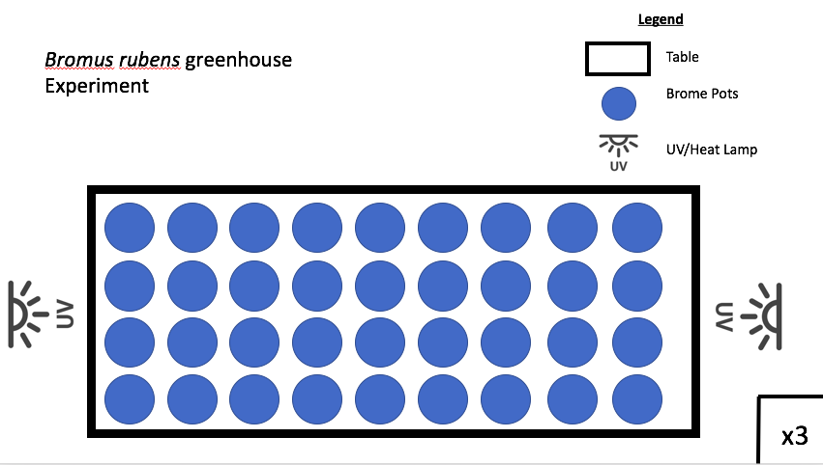

**Figure 1:** A rough schematic displaying the experimental design for the proposed experiment. A total of 3 tables were established with numerous pots containing native or exotic seeds. Each table will have heat lamps with varying light bulbs (40, 60 and 100Watts) to create a unique temperature for each table. The general location of both the Heat and UV lamps are shown to be on both sides of the tables and will be able to cover all pots.

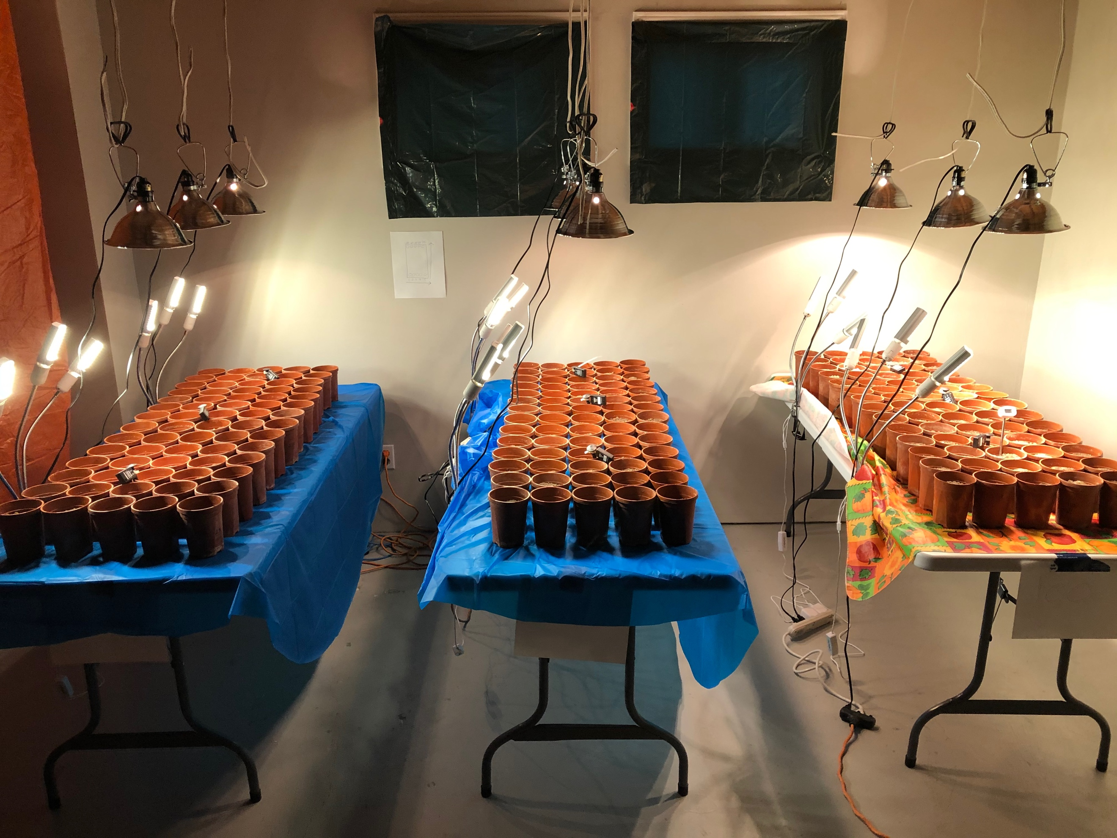

**Figure 2:** An image displaying the set-up of the temperature trials for this project. The overall temperature increases from left to right. A total of 70 pots have been placed on each table with a total surface area of 78.5cm2. Each table consists of 2 UV lamps (each with 3 adjustable heads) and 3 heat lamps positioned above the tables.

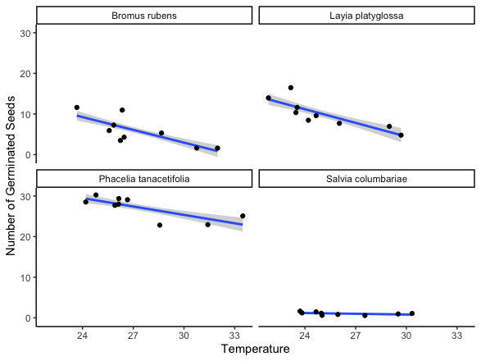

**Figure 3:** Mean germination of *Bromus rubens, Layia platyglossa, Phacelia tanacetifolia,* and *Salvia columbariae* against increasing temperatures (°C). Each trial was conducted separately and only one species was tested at a time. Standard error is represent a 95% shaded confidence interval.

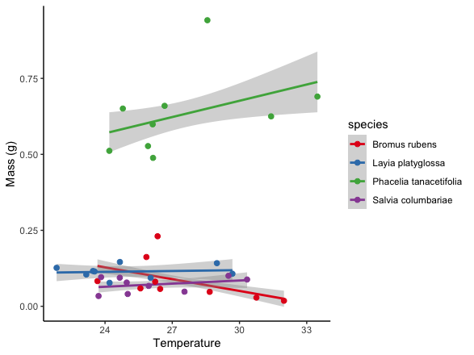

**Figure 4:** The relative effect of temperature on the mean mass of germinated plant individuals (g). All individuals within a pot were removed, dried, then weighed. Colored lines are specific to plant species with a shaded area showing a 95% confidence interval associated with the line of best fit.

**Progress to Date:**

The experiment has been completed as of the end of November 2021. Preliminary figures and statistics have been generated to display the findings of this experiment. We determined that temperature negatively impacts the germination of desert plant species (p < 0.001). This is true in terms of all tested individuals for the exception of

**Project 3: Shrub density effects on an endangered lizard of the San Joaquin Desert, California**

**Purpose:**

The purpose of this study was to test if the density of foundation shrub species can be used as an indicator for the overall habitat use by an endangered species of lizard, *Gambelia sila*, in the Carrizo Plain National Monument, through the use of a combination of radio telemetry tracking and satellite imagery.

**Hypothesis:**

*Gambelia sila* individuals will be found in areas of higher shrub density because of the benefits provided by shrubs.

**Predictions:**

1. Higher shrub density and cover predict increased estimated use by *G. sila*.
2. Higher shrub density and cover are associated with an increase in *G. sila* presence, both above and below ground.

**Progress to Date:**

We have geolacted all shrub individuals via google earth, combined the data with our 3-year radio telemetry dataset, and ground truthed a subset of the satellite located shrubs. This data has been analyzed and figures have been generated along with their corresponding statistics. The manuscript has been completed, edited and is currently under review at Ecosphere. The manuscript for this chapter is attached at the end of this document.

**Project 4: The Influence of High Shrub Density on local Vertebrate Association Across Varying Ecosystems**

**Purpose:**

The purpose of this chapter is to determine the association between vertebrate species and foundational shrub species at areas of high shrub density and areas absent of shrubs. Observable vertebrate species within the study site will be recorded to determine their association to these high densities and no density sites.

**Research Questions:**

* Will local vertebrate species show a higher association with high density areas or in no density areas?
* Is there significance in temperature between high density sites and no density sites?
* With the varying temperatures across increasing stress ecosystems affect animal associations?

**Hypothesis:**

Vertebrate abundance will be higher in areas of high *Ephedra californica* density, as individuals rely on the positive interactions associated with these foundational shrubs.

**Predictions:**

1. Vertebrate species abundance will be higher in areas of high *Ephedra californica* density than in areas absent of these shrub individuals.
2. With increasing micro and meso climate data, vertebrate individuals will be seen more frequently associated with shrubbed areas than open areas.
3. Higher stress ecosystems will have higher abundances of vertebrate species at shrubbed areas than lower stress ecosystems.

**Methods:**

**Study Sites:**

3 separate sites were used to conduction of this experiment. Cuyama (34.848726, -119.48312) acted as our relatively low stress site. This area of California sits at an elevation of 848 meters above sea level, has an average temperature of 19˚C, and has an average annual precipitation of 45cm. The main shrub species that dominates this site is *Ephedra californica*. The Carrizo Plain National Monument (35.11982, -119.62853) was used as this experiment’s medium stress site. This site sits at an elevation of 2697ft with an average temperature of 23˚C. The average precipitations of this site is about 25cm, however this site goes through several months with minimal no rain. The study site is also dominated by the shrub *Ephedra californica* with several invasive grass species including: *Bromus rubens*. The final site used to display a high stress environment will be the Tecopa, an area located within the Mojave Desert (35.851515, -116.18671). This site is also heavily dominated by the foundational shrub species *Ephedra californica*, with other shrub individuals such as *Larrea tridentata*. This area’s annual precipitation can reach a low of 8.9cm and temperatures as high as 38˚C.

**Study Species:**

Similar to the previous projects, the main shrub species that will be focused on in the experiment is *Ephedra californica*. This species is the dominant woody plant species in both the Panoche and the Carzzio field sites. This is a vital foundation species that could play a pinnacle role in the restoration of desert ecosystems in California (Lortie et al. 2018, Filazzola et al. 2018). This species is resilient and can survive large abiotic stressors, such as drought, extreme heat, and lack of nutrition, while also surviving mechanical damage, such as branch breaking or herbivory (Lortie et al. 2018). This species is particularly used by several species of vertebrate including the Blunt-Nosed Leopard Lizard (Noble et al 2016), Giant Kangaroo Rat (Prugh & Brashares, 2010), and San Joaquin Jack Rabbits.

There are several vertebrate species that are local to Cuyama, Carrizo National Monument, and Tecopa. Over the last few years we have compiled a list of species we have seen both through camera trap data and through visual observations. A total of 81 species have been observed and a list has been generated in the following github repo (https://github.com/cjlortie/California_desert_species/blob/gh-pages/data/animals.csv). These species include: California Horned Lizard, Western Rattlesnake, Bobcats, Coyotes, and Kit Foxes, just to name a few.

One of the key species observed at these sites is *Dipodomys ingens*, or the Giant Kangaroo Rat. This is a small rodent species that is listed as Federally Endangered. This species is known for creating interconnecting burrows throughout these arid ecosystems (Prugh & Brashares, 2010). These species consume the seeds found underneath shrub canopies, resulting in them showing high associations to foundational shrub species.

One other species that is frequently observed through camera traps in these sites is *Lepus californicus*, otherwise known as the Black-Tailed Jack Rabbit. This species is frequently found both in the Carrizo and Cuyama, and is most frequently observed through camera traps. This species typically consumes vegetation both in open areas and under shrub canopies (Johnson & Anderson 1984).

**Design:**

This chapter be conducted in the Carrizo Plain National Monument, Cuyama Valley, and the Tecopa. Within each site 4, 20m radius high shrub density plots, ranging from 10-13 shrub individuals, will be established along with 4, 20m radius no shrub density plots (**Figure 5**). The 3 sites had total of 24 plots be established, 12 consisting of high shrub density and 12 consisting of no shrub density.

**Camera Traps:**

2 cameras, VIKERI Model A1, will be placed at each plot (2 cameras x 24 plots = 48 camera traps deployed). Both of the cameras were stationed looking into its designated microsite and were placed at opposite ends. These cameras were angled to not directly face one another, reducing misfires caused by their individual activity. These traps remained at the site for the duration of the field season and receive regular maintenance every 3-4 days. Datasheets will consist of: date, rep, day, plot, density, animal presence, species (RTU), time block, actual time, behavior, and observations. Analysis of the data will be conducted to show the total number of hits in the areas that are classified based on the corresponding plot. Any photos of humans that coincidentally trigger the cameras will not be added and will be deleted.

**Temperature Measurement:**

Local temperature and relative humidity will be recorded using a Mengshen hand-held humidity reader. This data will be collected when the sites are initially established, maintained, and de-assembled. In addition, local measures of ambient temperature will be recorded using OMEGA USB loggers, which will be suspended above ground approximately 20cm on a stake. 2 pendants will be placed at each established plot. At high density microsites, the loggers will be placed under shrub canopy, while at no density microsites 2 loggers will be placed in the open. These loggers will remain within shrub and open microsites for the duration of the field experiment. Hourly temperatures will be logged (°C) by pendants and used to calculate daily mean and maxima.

**Proposed Analysis:**

All statistical analysis of this experiment will be conducted using the statistical program R. GLMs will be used to examine the relationship between high shrub density/no shrub density and vertebrate abundance. Mesohabitat and microhabitat temperature will be treated as covariates in the data. Comparison across ecosystems on shrub/open animal association will be conducted. Total vertebrate abundance will be treated as a quasipoisson with animal presence as a binomial. In addition, ANOVAs with Chi-squared tests will be performed where variables in the model are shown to be significant. Tuckey tests will be used for post-hoc analysis of the GLMMs to test the interactions.

**Schematics:**

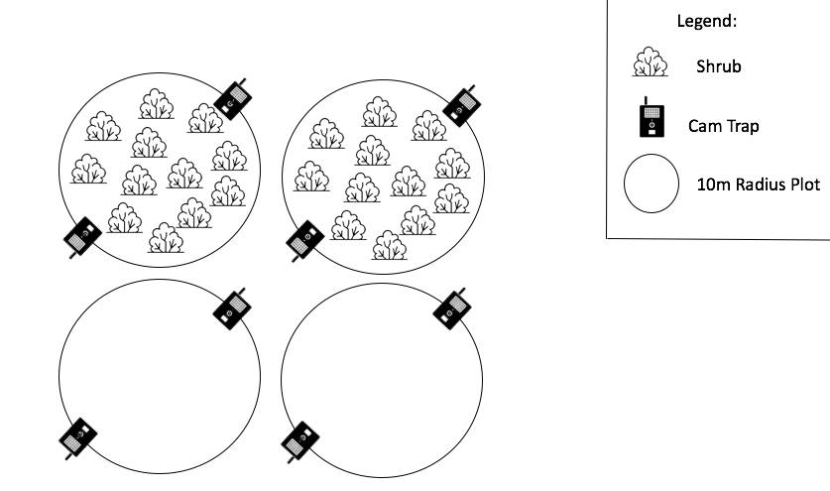

**Figure 5:** Schematic displaying the site establishment for project 4. A total of 24, 20m radius circular plots were established with 12 of these plots consisting of a high density of shrubs and 12 consisting of no shrubs. The general location of camera traps is also depicted and relate to each established plot.

**Progress to Date:**

This project was conducted this field season from May 2022 to early June 2022. All data has been collected for each established site. Camera trap data has been downloaded from the associated SD cards and is in the process of being processed for analysis. During the summer months of 2022 the camera trap data will be processed and then analyzed.

**Project 5: Impacts of Altered Foundational Shrub Densities on Vertebrate Association**

**Purpose:**

The purpose of this chapter is to examine the density-dependent associations between vertebrate species and foundational shrub species after systematic removal of shrub individuals. This is different from a landscape-level experiment, as individual shrubs will be removed and added to determine if shrub loss or addition is a factor in vertebrate association. Observable vertebrate species within the study site will be observed to determine their associations to these varying levels of foundational shrub density.

**Research Questions:**

* Will local vertebrate species respond to the reduction and removal of *Ephedra* individuals? If so to what extent?
* Will vertebrate species relocate to areas where removed shrubs are replanted? If so, then which vertebrate species?
* How will the complete removal of shrub individuals impact vertebrate species abundance and richness?

**Hypothesis:**

Vertebrate abundance will positively increase with increasing *Ephedra californica* densities, due to the positive interactions associated with this foundational shrub species.

**Predictions:**

1. Vertebrate species not previously present in areas absent *Ephedra* will display higher association to these new artificially established areas.
2. Vertebrate species abundance will be higher in areas with a high *Ephedra* density both in natural and artificial plots.
3. Vertebrate species richness will be higher in natural *Ephedra* plots.
4. Vertebrate species will prefer interacting with *Ephedra californica* individuals than in open areas and their composition will vary across shrub densities.
5. Vertebrate species will have a decreased association with artificially open plots.

**Methods:**

**Study Sites:**

The study sites for this project will be the same as Project 4. We will be focusing on a lower stress ecosystem (Cuyama), medium stress ecosystem (The Carrizo Plain National Monument), and a high stress ecosystem (The Heart of Mojave).

***Study Species:***

The study species for this project will be the same as Project 4. The target plant species for this chapter will be *Ephedra californica* as it is the dominant shrub species within the 3 Southern California sites.

***Design:***

This chapter will continue in the Carrizo Plain National Monument, Cuyama Valley, and the Heart of Mojave. In these sites, we will establish a total of 10, 20m radius circular plots. These plots will vary in total *Ephedra californica* density from 0 individuals (natural open plots) to around 10-11 (natural shrub plots). These plots will be denoted as “natural” plots. An additional 10, 20m radius circular plots will have their *Ephedra californica* densities altered through the systematic removal and transplantation of individuals (Holzapfel & Mahall 1999; Mahall et al. 2018). These removals create “artificial open” plots and the subsequent removed individuals will be transplanted into new locations creating “artificial shrub” plots. These new artificial shrub plots will resemble the natural shrub plots with a range from 2-12 *Ephedra californica* individuals. This will allow for a total of 20 plots established in the Carrizo Plain National Monument (**Figure 6**).

A brief side note, in the event that we are not given permission to remove shrub individuals from each site, we will construct shrub replicates to test the variation of vertebrate association to varying shrub densities. These shrub replicates will consist of a rebar center (acting as the trunk of the shrub) with cloth material wrapped around it to simulate shrub cover.

**Camera Traps:**

2 cameras will be placed at each plot (2 cameras x 20 plots = 40 camera traps deployed). Both of the cameras will be stationed looking into its designated microsite and will be placed at opposite sides. These cameras will be angled to not directly face one another to reduce misfires caused by their individual activity. These traps will remain at the site for the duration of the field season and receive regular maintenance every 3-4 days. Datasheets will consist of: date, rep, day, plot, density (corresponding to “pseudo shrub” density), animal presence, species (RTU), time block, actual time, behavior, and observations. From there, an analysis will be conducted to show the total number of hits in the areas that are classified based on the corresponding “artificial shrub” plot. Any photos of humans that coincidentally trigger the cameras will not be added and will be deleted.

**Focal Observations:**

The final portion of this chapter includes the conduction of several hours of focal observations. Several hours throughout the duration of the field season, researchers will monitor plots and observe associated vertebrate species. These observations will be conducted between 8:00AM and 6:00PM every 4-5 days at each established plot. This allows a better understanding of the total abundance of vertebrate species in the area, allows for the validation of camera trap triggers, and will aid in species validation and identification.

**Temperature Measurement:**

Local measures of ambient temperature will be recorded using OMEGA pendant loggers, which will be suspended above ground approximately 20cm on a stake. 2 pendants will be placed at each established plot, one located underneath a shrub canopy and another located in the open. These pendants will remain within shrub and open microsites for the duration of the field experiment. Hourly temperatures will be logged (°C) by pendants and used to calculate daily mean and maxima.

**Dry Matter and Vegetation Identification:**

Dry matter is the measure of the total mass of varying grass and vegetation species in a given area (Bartolome 2002; Filazzola et al. 2017). Dry matter will be collected by placing a 20cm x 20cm square randomly at both shrub and open microsites at each shrub density plot. All grass within the indicated square will be removed entirely from the ground and weighed on a digital scale to determine the total mass of vegetation growing. This estimate will be done at each plot a total of six times per plot where three samples will be located under shrub canopies and three samples will be taken in the open. Plots that do not contain three shrubs within will have all possible shrub sampled and open microsites. Before removal of dry matter local matter both underneath shrub canopies and in open areas will be identified, using California plant identification guides, and overall abundance of each species will be recorded.

**Proposed Analysis:**

All statistical analysis of this experiment will be conducted using the statistical program R. GLMMs will be used to examine the relationship between shrub density and overall vertebrate abundance. Dry matter and temperature will be treated as covariates. Total vertebrate abundance will be treated as a quasipoisson with animal presence as a binomial. In addition, ANOVAs with Chi-squared tests will be performed where variables in the model are shown to be significant. Tuckey tests will be used for post-hoc analysis of the GLMMs to test the interactions.

**Chapter 5 Schematics:**

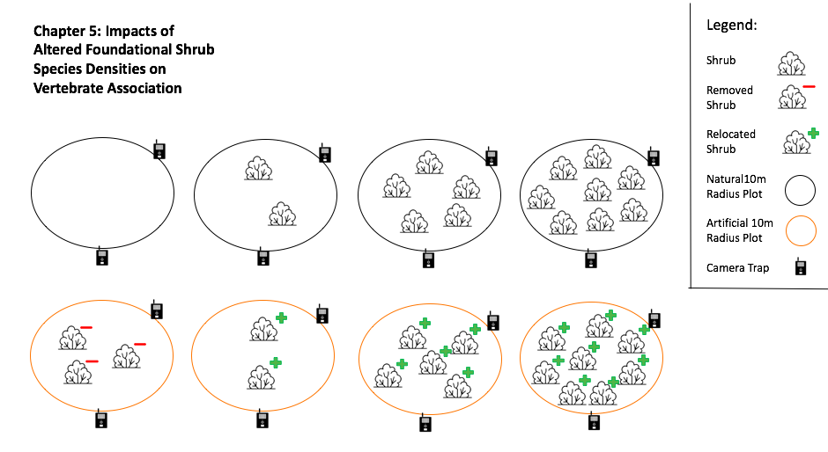

**Figure 6:** A rough schematic displaying this experiment’s potential design. A total of 20, 20m radius circular plots will be established with a range of ephedra individuals located within each established plot. 10 of the established plots will be naturally established while 10 plots will have shrubs artificially planted. The general location of camera traps is also depicted and relate to each established plot.

**Progress to Date:**

We have decided to conduct this project the upcoming 2023 field season from May to June 2023. All camera traps, pendants and SD cards have been purchased and are ready for use. We are currently working on acquiring permits to conduct the shrub removal portion of the project. If this is not successful then shrub replicates we be deployed instead, as previously outlines in this project.

**Literature Cited:**

Adams, E. S., & Tschinkel, W. R. (1995). Density-Dependent Competition in Fire Ants: Effects on Colony Survivorship and Size Variation. The Journal of Animal Ecology, 64(3), 315. <https://doi.org/10.2307/5893>

Adams, J. D., Wall, M., & Garcia, C. (2005). Salvia columbariae contains tanshinones. Evidence-Based Complementary and Alternative Medicine, 2(1), 107–110. <https://doi.org/10.1093/ecam/neh067>

Anderson, M, K. (2006). Tending the Wild: Native American Knowledge and the Management of California’s Natural Resources.

Antonovics, J., & Levin, D. A. (1980). The Ecological and Genetic Consequences of Density-Dependent Regulation in Plants. Annual Review of Ecology and Systematics, 11(1), 411–452. <https://doi.org/10.1146/annurev.es.11.110180.002211>

Araújo, M. B., & Rozenfeld, A. (2013). The geographic scaling of biotic interactions. Ecography, no-no. <https://doi.org/10.1111/j.1600-0587.2013.00643.x>

Auger, J., Meyer, S. E., & Jenkins, S. H. (2016). A mast-seeding desert shrub regulates population dynamics and behavior of its heteromyid dispersers. Ecology and Evolution, 6(8), 2275–2296. <https://doi.org/10.1002/ece3.2035>

Badano, E. I., Samour-Nieva, O. R., Flores, J., Flores-Flores, J. L., Flores-Cano, J. A., & Rodas-Ortíz, J. P. (2016). Facilitation by nurse plants contributes to vegetation recovery in human-disturbed desert ecosystems. Journal of Plant Ecology, 9(5), 485–497. <https://doi.org/10.1093/jpe/rtw002>

Bartolome, J. W., W. E. Frost, N. K. McDougald, and M. Connor. 2002. California guidelines for residual dry matter (RDM) management on coastal and foothill annual rangelands. Agriculture and Natural Resources Publication 8092:1-7.

Bertness, M. D., & Callaway, R. (1994). Positive interactions in communities. Trends in Ecology & Evolution, 9(5), 191–193. <https://doi.org/10.1016/0169-5347(94)90088-4>

Bertness, M. D., & Leonard, G. H. (1997). The Role of Positive Interactions in Communities: Lessons from Intertidal Habitats. Ecology, 78(7), 1976. <https://doi.org/10.2307/2265938>

Bond W.J. (1994) Keystone Species. In: Schulze ED., Mooney H.A. (eds) Biodiversity and Ecosystem Function. Springer, Berlin, Heidelberg.

Brooker, R. W., Maestre, F. T., Callaway, R. M., Lortie, C. L., Cavieres, L. A., Kunstler, G., Liancourt, P., Tielbörger, K., Travis, J. M. J., Anthelme, F., Armas, C., Coll, L., Corcket, E., Delzon, S., Forey, E., Kikvidze, Z., Olofsson, J., Pugnaire, F., Quiroz, C. L., … Michalet, R. (2007). Facilitation in plant communities: The past, the present, and the future. Journal of Ecology, 0(0), 070908024102002- ??? <https://doi.org/10.1111/j.1365-2745.2007.01295.x>

Butterfield, B. J., Bradford, J. B., Armas, C., Prieto, I., & Pugnaire, F. I. (2016). Does the stress‐gradient hypothesis hold water? Disentangling spatial and temporal variation in plant effects on soil moisture in dryland systems. Functional Ecology, 30(1), 10–19. [https://doi.org/10.1111/1365- 2435.12592](https://doi.org/10.1111/1365-2435.12592)

Callaway, R. M., Brooker, R. W., Choler, P., Kikvidze, Z., Lortie, C. J., Michalet, R., Paolini, L., Pugnaire, F. I., Newingham, B., Aschehoug, E. T., Armas, C., Kikodze, D., & Cook, B. J. (2002). Positive interactions among alpine plants increase with stress. Nature, 417(6891), 844–848. <https://doi.org/10.1038/nature00812>

Dangles, O., Herrera, M., & Anthelme, F. (2013). Experimental support of the stress-gradient hypothesis in herbivore-herbivore interactions. New Phytologist, 197(2), 405–408. <https://doi.org/10.1111/nph.12080>

Dangles, O., Herrera, M., Carpio, C., & Lortie, C. J. (2018). Facilitation costs and benefits function simultaneously on stress gradients for animals. Proceedings of the Royal Society B: Biological Sciences, 285(1885), 20180983. <https://doi.org/10.1098/rspb.2018.0983>

Eldridge, D. J., & Soliveres, S. (2014). Are shrubs really a sign of declining ecosystem function? Disentangling the myths and truths of woody encroachment in Australia. Australian Journal of Botany, 62(7), 594. <https://doi.org/10.1071/BT14137>

Ellison, A. M. (2019). Foundation Species, Non-trophic Interactions, and the Value of Being Common. IScience, 13, 254–268. <https://doi.org/10.1016/j.isci.2019.02.020>

Filazzola, A., & Lortie, C. J. (2014). A systematic review and conceptual framework for the mechanistic pathways of nurse plants: A systematic review of nurse-plant mechanisms. Global Ecology and Biogeography, 23(12), 1335–1345. <https://doi.org/10.1111/geb.12202>

Filazzola, A., & Lortie, C. J. (2014). A systematic review and conceptual framework for the mechanistic pathways of nurse plants: A systematic review of nurse-plant mechanisms. Global Ecology and Biogeography, 23(12), 1335–1345. <https://doi.org/10.1111/geb.12202>

Germano, D. J., & Rathbun, G. B. (2016). Home Range and Habitat Use by Blunt-nosed Leopard Lizards in the Southern San Joaquin Desert of California. Journal of Herpetology, 50(3), 429–434. <https://doi.org/10.1670/15-006>

Greenfield, M. D., Shelly, T. E., & Gonzalez-Coloma, A. (1989). Territory Selection in a Desert Grasshopper: The Maximization of Conversion Efficiency on a Chemically Defended Shrub. The Journal of Animal Ecology, 58(3), 761. <https://doi.org/10.2307/5122>

Hart, S. P., & Marshall, D. J. (2013). Environmental stress, facilitation, competition, and coexistence. Ecology, 94(12), 2719–2731. <https://doi.org/10.1890/12-0804.1>

Holzapfel, C., & Mahall, B. E. (1999). Bidirectional Facilitation and Interference between Shrubs and Annuals in the Mojave Desert. Ecology, 80(5), 1747–1761. [https://doi.org/10.1890/0012- 9658(1999)080[1747:BFAIBS]2.0.CO;2](https://doi.org/10.1890/0012-9658(1999)080%5B1747:BFAIBS%5D2.0.CO;2)

Hughes, A. R. (2012). A neighboring plant species creates associational refuge for consumer and host. Ecology, 93(6), 1411–1420. <https://doi.org/10.1890/11-1555.1>

Ivey, K. N., Cornwall, M., Crowell, H., Ghazian, N., Nix, E., Owen, M., Zuliani, M., Lortie, C. J., Westphal, M., & Taylor, E. (2020). Thermal ecology of the federally endangered blunt-nosed leopard lizard (Gambelia sila). Conservation Physiology, 8(1), coaa014. <https://doi.org/10.1093/conphys/coaa014>

Johnson, R. D., & Anderson, J. E. (1984). Diets of black-tailed jack rabbits in relation to population density and vegetation. Journal of Range Management, 37(1), 79-83.

Kéfi, S., Holmgren, M., & Scheffer, M. (2016). When can positive interactions cause alternative stable states in ecosystems? Functional Ecology, 30(1), 88–97. [https://doi.org/10.1111/1365- 2435.12601](https://doi.org/10.1111/1365-2435.12601)

Kikvidze, Z., & Callaway, R. M. (2009). Ecological Facilitation May Drive Major Evolutionary Transitions. BioScience, 59(5), 399–404. <https://doi.org/10.1525/bio.2009.59.5.7>

Lortie, C. J., Filazzola, A., & Sotomayor, D. A. (2016). Functional assessment of animal interactions with shrub‐facilitation complexes: A formal synthesis and conceptual framework. Functional Ecology, 30(1), 41–51. <https://doi.org/10.1111/1365-2435.12530>

Lortie, C. J., Gruber, E., Filazzola, A., Noble, T., & Westphal, M. (2018). The Groot Effect: Plant facilitation and desert shrub regrowth following extensive damage. Ecology and Evolution, 8(1), 706–715. <https://doi.org/10.1002/ece3.3671>

Lortie, C. J., Zuliani, M., Ghazian, N., Haas, S., Braun, J., Owen, M., Miguel, F., Seifan, M., Filazzola, A., & Lucero, J. (2021). Too much of a good thing: Shrub benefactors are less important in higher diversity arid ecosystems. Journal of Ecology, 1365-2745.13596. [https://doi.org/10.1111/1365- 2745.13596](https://doi.org/10.1111/1365-2745.13596)

Lortie, C. J., Ghazian, N., & Zuliani, M. (2022). A workflow for selecting seeding density in desert species experiments. Journal of Arid Environments, 198, 104701. <https://doi.org/10.1016/j.jaridenv.2021.104701>

Lucero, J. E., & Callaway, R. M. (2018). Native granivores reduce the establishment of native grasses but not invasive Bromus tectorum. Biological Invasions, 20(12), 3491–3497. <https://doi.org/10.1007/s10530-018-1789-x>

Lucero, J. E., Noble, T., Haas, S., Westphal, M., Butterfield, H. S., & Lortie, C. J. (2019). The dark side of facilitation: Native shrubs facilitate exotic annuals more strongly than native annuals. NeoBiota, 44, 75–93. <https://doi.org/10.3897/neobiota.44.33771>

Maestre, F. T., Bowker, M. A., Puche, M. D., Belén Hinojosa, M., Martínez, I., García-Palacios, P., Castillo, A. P., Soliveres, S., Luzuriaga, A. L., Sánchez, A. M., Carreira, J. A., Gallardo, A., & Escudero, A. (2009). Shrub encroachment can reverse desertification in semi-arid Mediterranean grasslands. Ecology Letters, 12(9), 930–941. <https://doi.org/10.1111/j.1461-0248.2009.01352.x>

Maestre, F. T., Eldridge, D. J., Soliveres, S., Kéfi, S., Delgado-Baquerizo, M., Bowker, M. A., García- Palacios, P., Gaitán, J., Gallardo, A., Lázaro, R., & Berdugo, M. (2016). Structure and Functioning of Dryland Ecosystems in a Changing World. Annual Review of Ecology, Evolution, and Systematics, 47(1), 215–237. <https://doi.org/10.1146/annurev-ecolsys-121415-032311>

Molina-Montenegro, M. A., Oses, R., Acuña-Rodríguez, I. S., Fardella, C., Badano, E. I., Torres-Morales, P., Gallardo-Cerda, J., & Torres-Díaz, C. (2016). Positive interactions by cushion plants in high mountains: Fact or artifact? Journal of Plant Ecology, 9(2), 117–123. <https://doi.org/10.1093/jpe/rtv044>

Moore, D., Stow, A., & Kearney, M. R. (2018). Under the weather?-The direct effects of climate warming on a threatened desert lizard are mediated by their activity phase and burrow system. Journal of Animal Ecology, 87(3), 660–671. <https://doi.org/10.1111/1365-2656.12812>

Musick, H. B., Schaber, G. S., & Breed, C. S. (1998). AIRSAR Studies of Woody Shrub Density in Semiarid Rangeland: Jornada del Muerto, New Mexico. 12.

Noble, T. J., Lortie, C. J., Westphal, M., & Butterfield, H. S. (2016). A picture is worth a thousand data points: An imagery dataset of paired shrub-open microsites within the Carrizo Plain National Monument. GigaScience, 5(1), 40. <https://doi.org/10.1186/s13742-016-0145-2>

Owayss, A. A., Shebl, M. A., Iqbal, J., Awad, A. M., Raweh, H. S., & Alqarni, A. S. (2020). Phacelia tanacetifolia can enhance conservation of honey bees and wild bees in the drastic hot-arid subtropical Central Arabia. Journal of Apicultural Research, 59(4), 569–582. <https://doi.org/10.1080/00218839.2020.1735731>

Parmenter, R. R., & MacMahon, J. A. (1983). Factors determining the abundance and distribution of rodents in a shrub-steppe ecosystem: The role of shrubs. Oecologia, 59(2–3), 145–156. <https://doi.org/10.1007/BF00378831>

Pebesma, Ed. (2018). Simple Features for R: Standardized Support for Spatial Vector Data, 8.

Prugh, L., & Brashares, J. (2010). Basking in the moonlight? Effect of illumination on capture success of the endangered giant kangaroo rat. Journal of Mammalogy, 91(5), 1205–1212. <https://doi.org/10.1644/10-MAMM-A-011.1>

Rey, P. J., Cancio, I., Manzaneda, A. J., González-Robles, A., Valera, F., Salido, T., & Alcántara, J. M. (2018). Regeneration of a keystone semiarid shrub over its range in Spain: Habitat degradation overrides the positive effects of plant-animal mutualisms. Plant Biology, 20(6), 1083–1092. <https://doi.org/10.1111/plb.12870>

Salo, L. F. (2005). Red brome (Bromus rubens subsp. madritensis) in North America: Possible modes for early introductions, subsequent spread. Biological Invasions, 7(2), 165–180. <https://doi.org/10.1007/s10530-004-8979-4>

Simberloff, D. (2006). Invasional meltdown 6 years later: Important phenomenon, unfortunate metaphor, or both? Ecology Letters, 9(8), 912–919. <https://doi.org/10.1111/j.1461-0248.2006.00939.x>

Sirami, C., Seymour, C., Midgley, G., & Barnard, P. (2009). The impact of shrub encroachment on savanna bird diversity from local to regional scale. Diversity and Distributions, 15(6), 948–957. <https://doi.org/10.1111/j.1472-4642.2009.00612.x>

Soulé, M. E., Estes, J. A., Miller, B., & Honnold, D. L. (2005). Strongly Interacting Species: Conservation Policy, Management, and Ethics. BioScience, 55(2), 168. [https://doi.org/10.1641/0006-3568(2005)055[0168:SISCPM]2.0.CO;2](https://doi.org/10.1641/0006-3568(2005)055%5B0168:SISCPM%5D2.0.CO;2)

Springer, T. L., Dewald, C. L., Sims, P. L., & Gillen, R. L. (2003). How Does Plant Population Density Affect the Forage Yield of Eastern Gamagrass? Crop Science, 43(6), 2206–2211. <https://doi.org/10.2135/cropsci2003.2206>

Stachowicz, J. J. (2001). Mutualism, Facilitation, and the Structure of Ecological Communities. BioScience, 51(3), 235. [https://doi.org/10.1641/0006-3568(2001)051[0235:MFATSO]2.0.CO;2](https://doi.org/10.1641/0006-3568(2001)051%5B0235:MFATSO%5D2.0.CO;2)

Tilman, D., Isbell, F., & Cowles, J. M. (2014). Biodiversity and Ecosystem Functioning. Annual Review of Ecology, Evolution, and Systematics, 45(1), 471–493. <https://doi.org/10.1146/annurev-ecolsys-120213-091917>

Tietje, W. D., Lee, D. E., & Vreeland, J. K. (2008). Survival and Abundance Of Three Species Of Mice In Relation to Density Of Shrubs and Prescribed Fire In Understory Of An Oak Woodland In California. The Southwestern Naturalist, 53(3), 357–369. <https://doi.org/10.1894/PS-35.1>

Turner, R. M., Alcorn, S. M., Olin, G., & Booth, J. A. (1966). The Influence of Shade, Soil, and Water on Saguaro Seedling Establishment. Botanical Gazette, 127(2/3), 95–102. <https://doi.org/10.1086/336348>

Van Auken, O.W. 2009. “Causes and Consequences of Woody Plant Encroachment into Western North American Grasslands.” Journal of Environmental Management 90 (10): 2931–42. https://doi.org/10.1016/j.jenvman.2009.04.023.

Vázquez, D. P., Blüthgen, N., Cagnolo, L., & Chacoff, N. P. (2009). Uniting pattern and process in plant– animal mutualistic networks: A review. Annals of Botany, 103(9), 1445–1457. <https://doi.org/10.1093/aob/mcp057>

Westphal, M. F., Noble, T., Butterfield, H. S., & Lortie, C. J. (2018). A test of desert shrub facilitation via radiotelemetric monitoring of a diurnal lizard. Ecology and Evolution. <https://doi.org/10.1002/ece3.4673>

Westphal, M. F., Stewart, J. A. E., Tennant, E. N., Butterfield, H. S., & Sinervo, B. (2016). Contemporary drought and future effects of climate change on the endangered

blunt-nosed leopard lizard, *Gambelia sila*. PLOS ONE, 11(5), e0154838. <https://doi.org/10.1371/journal.pone.0154838>

Zuliani, M., Ghazian, N., & Lortie, C. J. (2021). Shrub density effects on the community structure and composition of a desert animal community. Wildlife Biology, 2021(2). <https://doi.org/10.2981/wlb.00774>

**A meta-analysis of shrub density as a predictor of animal abundance.**

**Abstract**

Facilitative interactions between shrub and animal species can shape the structure and composition of various ecosystems. Here, we tested whether the density of woody plants such as shrubs can be used to predict the local abundance of animal populations in a meta-analysis. Keyword searches on ISI Web of Science using “density”, “facil*”, “shrub*”, and “animal*” returned 753 studies. Full-text review for shrub density, animal abundance or density, and sampling effort, resulted in a total of 113 independent observations that reported shrub density and animal abundance. We tested for the possible relationship between shrub density and local animal abundances through the use of a meta-regression. Woody shrub density positively predicted animal abundance, particularly in desert and grassland ecosystems. Shrub density can be used as an effective measure in predicting local animal abundances for wildlife biology, while assisting the restoration and preservation of these animal species.

**Keywords:** plantdensity, meta-analysis, facilitation, abundance, population, density-dependent, shrubs, plants

**Introduction**

The measure of animal abundance ecological studies is a fundamental tool used both at local and landscape levels. There are several different characteristics that ecologists can use to describe the population of species (Ferguson et al. 2000; Walker 2011). Density is a relatively simple variable used to predict the overall abundance of organisms in varying ecosystems. In ecology, density is defined as the number of animal or plant individuals per unit area (Lyon 1968). This practice has previously been used to determine community structure and composition in some population-based studies (Antonovics & Levin, 1980; Adams & Walters 1995), while also giving insight into trophic interactions (Nilsson 2001; Laundré & Hernández 2003; McPeek 2019). The density of both plant and animal species directly relates to density-dependent associations, which are typically seen as the regulation of population growth rates (Ray & Hastings 1996; Jenkins et al. 1999). In terms of plant-animal associations, plant density can influence the net outcome of animal associations, thus impacting community composition (Springer et al. 2003). Shrub density itself both directly and indirectly influence animal associations, specifically in arid and semi-arid ecosystems (Zuliani et al. 2021). In arid ecosystems such as scrublands, increasing levels of shrub density have a net positive influence on species abundance, as smaller animals utilize these areas for habitat and shelter from predation (Nelson et al. 2007; Filazzola et al. 2017; Lortie 2020), act as a refuge (Valone & Balaban-Feld 2019), act as a food source (Lortie 2020), and reduce harsh abiotic conditions (Ivey et al. 2020). This in turn has a positive contribution to the overall health of the ecosystem through the reversal of desertification (Maestre et al. 2009; Sirami et al. 2009). These shrub densities will impact local animal species in varying ecosystems allowing for more trophic and non-trophic interactions to occur.

Interacting individuals can experience both negative and positive associations, with positive associations becoming the main focus of ecological studies in recent years. These positive associations are typically the main focus of many plant-plant studies (Stachowicz 2001; Kikvidze & Callaway 2009; Van der Merwe et al. 2021); however, this can also apply to many plant-animal associations (Westphal et al. 2018; Zuliani et al. 2021). Facilitation is a non-trophic interaction between species where at least one individual benefits, while the other either benefits or is unaffected (Montenegro et al. 2016). Shrub individuals, such as *Ephedra californica* (Mormon tea) and *Caragana korshinskii* (Korshinski pea shrub), act as foundational species as they are the source of beneficial interactions with both plant and animal species (Bittick et al. 2019, Lortie et al. 2020). The density of shrub individuals can influence the associations seen by animal species (Zuliani et al. 2021), increasing both direct and indirect associations (Adams & Walters 1995), allowing for more complex trophic interactions (Schneider et al. 2016). These facilitative interactions play a defining role in various ecosystems worldwide (Callaway 2007; Verwijmeren et al. 2013), as they provide environmental benefits through microclimatic buffering (Kefi et al. 2008), providing refuge for animals during extreme conditions by lowering the amplitude of environmental variation (Holzapfel & Mahall 1999; Fillazola et al. 2017). With the importance of shrub density and their corresponding facilitative interactions playing a crucial role in community composition, this variable can be used as a potential predictor of animal density and abundance in varying ecosystems.

In this study, we conducted an in-depth systematic review and meta-analysis of the peer-reviewed literature to test the hypothesis that shrub density can directly predict animal abundance. We also propose that this relationship between density and animal abundance is ecosystem-specific. The purpose of this review is to connect shrub density to animal abundance, as it could prove to be a key tool for managers and conservation specialists who work to preserve animal populations in distributed regions.

**Methods**

***Literature Review***

To explore the use of shrub density as an indicator for animal abundance and density, we surveyed the literature using a combination of the keywords: 1) “density”, “abundance”, “facil*”, “shrub”, AND “animal”, 2) “density”, “facil*”, “abundance”, AND “shrub”, 3) “density”, “abundance”, “shrub”, in the ISI Web of Science database (Web of Science 2021). We used additional literature searches on Google Scholar to validate listed articles from Web of Science in June 2021. A total of 532 articles were screened for their potential inclusion in our meta-analysis. A PRISMA diagram was generated to illustrate the inclusion process (Moher 2009) (Appendix A Figure S1). The main text of the articles was screened using the following criteria: (1) interaction between shrub species and local animals reported, (2) sample area(s) were defined, (3) shrub density and animal abundance reported, and (4) total study duration reported. Studies that included all criteria for the exception of a recorded shrub density or animal abundance were not included in this review as they did not provide any quantifiable data that could be used.

Densities were recorded for all woody shrub and animal species. A common unit of shrub density was derived by converting all observations into one common unit (number of individuals per km2). Animal abundance was recorded for each incorporated study as the number of individuals per unit area. Animals belonged to all taxa including vertebrates and arthropods. The names of the target shrub, including *Ephedra californica*, *Caragana microphylla*, and *Caragana korshinskii*,and animal species were recorded from each study, in addition to the total duration of the study (number of days). Studies reporting the number of years conducted were converted into days. Finally, the main macrohabitat of each study was recorded. Macrohabitat was defined as the target ecosystem of the corresponding study, such as desert, grassland, or tundra. All collected data is available on the Knowledge Network of Biocomplexity (Zuliani et al. 2021).

***Meta-Analyses***

All statistical analyses were done using R version 4.1.0 (R Core Team, 2010), and code is available on GitHub (Zuliani 2021). Effect sizes were calculated using the reported density of target shrub species and overall animal abundance, each acting as an independent variable. The *escalc* function from the *metafor* package was used to estimate the incidence rates by dividing the shrub densities by the number of days (Viechtbauer 2010). The *metafor* package was also used to conduct a random-effect meta-regression to analyze estimated values of the animal abundance and shrub density (Viechtbauer 2010). The meta-regression was weighted by the duration of each study (number of days). The Maximum likelihood (ML) method was used to estimate the animal abundance in relation to shrub density, in combination with a Knapp-Hartung Method (KNHA) test, with macrohabitat set as a moderator (Hartung & Knapp, 2001). The heterogeneity of all models was examined using Cochran’s Q test (Chochran 1950) to ensure that the variance in data was not a result of inflation from grouping (Langan et al. 2019; Page et al. 2021).

**Results**

A total of 753 articles were obtained through the search of the previously outlined keywords (Appendix A, Figure S1). After a full-text review, a total of 113 unique data points included shrub density and animal abundance was extracted. The most common ecosystem recorded amongst collected studies was desert at 75% of the observations, and grassland comprised the remaining 25% of observations. Three unique shrub species were observed for their effects on animal abundance including; *Ephedra californica,* *Caragana korshinskii*, and *Caragana microphylla* (Littleleaf Peashrub). All recorded animal species were native to their corresponding ecosystem. Shrub density significantly predicted the overall abundance of animal individuals throughout all collected studies (Figure 1,1.9729 ±0.2826, p <0.0001, *df* = 108). Ecosystem was a significant moderator of animal abundance (Figure 2, F = 24.6641, p < 0.001, *df* = 2). The effects of shrub density on animal abundance were positive in grasslands, but negative in desert ecosystems (Figure 1, heterogeneity p <0.0001). There was a significant effect of shrub species on animal abundance (F = 18.6144, p <0.0001, *df* = 3). The effect of shrub species density was positive for *Caragana korshinskii*, but negative for *Ephedra californica* individuals (Figure 3, heterogeneity p <0.0001).

**Discussion**

The use of density as a predictor of animal abundance is a critical tool in the determination of community composition. The meta-analysis supported the hypothesis that shrub density can act as an indicator of local animal abundance. Both grassland and desert ecosystems are significant environments where shrub density can predict animal abundances. In addition, *Caragana korshinski* and *Ephedra californica* were two shrub species recorded to have a significant influence on animal abundance.

Studies used in this meta-analysis, such as Filazzola et al. (2017) and Zuliani et al. (2021) test if shrubs in arid ecosystems have an impact on animal associations by examining overall shrub density. The beneficial associations between shrub individuals and local animal communities suggest that interactions occur at higher frequencies in areas with a higher shrub density than in areas with little to no individuals (Zuliani et al. 2021). This higher frequency of interactions will allow for more beneficial associations to occur and thus will positively impact both plant and animal species. Many of the studies used in this meta-analysis show foundational shrub species and various animal species that associate with them (Westphal et al. 2018; Zuliani et al. 2021). These foundational plant species are individuals who play a pinnacle role in the association of animal species and can support various ecosystem functions (Filazzola et al. 2020, Zuliani et al. 2021). Foundational shrub species, such as *Ephedra californica,* facilitate these beneficial interactions with various species (Westphal et al. 2018; Braun et al. 2020), while also buffering extreme environmental conditions such as solar radiation, temperature, and wind (Pugnaire 2010; Ivey et al.2020). While these foundational plant species can prove to be beneficial for native communities, the promotion and growth of various invasive species can occur, thus potentially degrading local ecosystems and negatively impacting native species (Lortie et al. 2021). Invasive species, such as *Bromus rubens,* positively benefit from foundational shrub species which can exacerbate biological invasion (Lucero et al. 2019; Lortie et al. 2021). The promotion of invasive species through these positive associations can potentially lead natives being outcompeted for habitat and resources (Lortie et al. 2021). With the influence foundational plants have on both plant and animal species, it can be extrapolated that the density of these shrubs could have a potential role in both native and invasive succession in arid ecosystems. Therefore, shrub density can allow for these associations to occur, while also serving as a potential proxy for predicting animal abundances.

Associations between foundational species with local plant and animal individuals can be seen through various direct and indirect mechanisms. In particular, facilitative interactions can play a pinnacle role in various ecological communities, thus influencing the overall composition of local animal species. This association could be explained by several mechanisms associated with foundational species. These shrubs can positively associate with animals through; acting as a refuge (Valone & Balaban-Feld 2019), temperature amelioration (Westphal et al. 2018; Ivey et al. 2020), predation avoidance (Filazzola et al. 2017), augmentation of resources through seed trapping (Bullock & Moy 2004), and production of fruit (Hertel et al. 2018). Having a higher availability of shrubs in an area can further amplify these benefits to animals as these resources are made more abundant and accessible (Auger et al. 2016; Zuliani et al. 2021). Some species, specifically small rodents, have been observed to consume seeds from shrub species, further suggesting that the overall availability and abundance of resources can influence animal association (Auger et al. 2016; Valone & Balaban-Feld 2019). It can then be assumed that animal individuals that are reliant on these associations with shrubs to survive would be more likely found in these high shrub density areas. Furthermore, it is important to evaluate these density-dependent associations among multiple animal and shrub species simultaneously as these individuals interact both directly and indirectly in various complex assemblages in nature. While the species that associate with these foundational shrubs may directly benefit, the probability of more complex trophic interactions increases due to the variation in community composition (Van der Putten et al. 2004). Numerous indirect feedbacks may also result from this positive association including varying foraging herbivores (Kotler et al. 1991) as well as the association of predator species (Carbone et al. 2011). Predator species, such as *Crotalus oreganus* (Northern Pacific Rattlesnake), consume smaller vertebrates (Holding et al. 2018) which use shrub species as a refuge from predators, thus impacting community composition and association. These multitrophic interactions will produce richer and more diverse associations than those seen through a single trophic level (Duffy et al. 2007). Hence, we suggest that studies looking at associations between shrub and animal species consider the density of these shrub individuals in their studies as it has the potential to act as a direct indicator for animal abundance, while also influencing both trophic interactions and community composition.

**Implications**

This meta-analysis quantitatively supports that shrub density can predict local animal abundance in varying arid ecosystems. Specifically, shrub density should be considered when conducting ecological studies focusing on the abundance of a target animal species, and those that observe local community compositions, as it is a relatively simple variable to record and can be used to directly analyze animal associations. With the current increase in desertification of arid-ecosystems impacting at risk and endangered species, the implications of shrub density on both animal associations and environmental health can prove to be a vital tool in conservation and restoration. Current conservation and restorative practices of endangered species would greatly benefit from recording shrub density as it can provide insight into interactions and associations experience by these individuals while also acting as a potential proxy in determining that species local abundance. Our results provide new and novel insights into the use of density as it has the potential to be used for restorative and conservative practices. Based on our observations, it is evident that shrub density should be further reported in plant-animal interaction studies. It is evident from our findings that density of shrub individuals is not considered when observing animal abundance in ecological literature. We recommend that these studies, focusing on animal abundance in arid ecosystems, consider reporting the overall density of shrub individuals to strengthen our current understanding of density and its implications. In addition, our study was not meant to imply that animal species require shrubs to survive, rather it is meant to show that shrubs can be of use to local animal populations. Future research can potentially continue observing these associations to further support this theory that shrub densities can be used as a potential means to predict animal abundance.

**Acknowledgments**

This research was made possible through a Natural Sciences and Engineering Research Council of Canada (NSERC) grant awarded to CJL. MZ, NG, and CJL declare no conflict of interest.

**Author**’**s contributions**

MZ and CJL designed the study and methodologies; MZ, NG, and CJL analyzed the data; MZ and CJL wrote the manuscript; NG thoroughly edited the manuscript.

**References:**

Adams, Eldridge S., and Walter R. Tschinkel. 1995. “Density-Dependent Competition in Fire Ants: Effects on Colony Survivorship and Size Variation.” *The Journal of Animal Ecology* 64 (3): 315.

Antonovics, J, and D A Levin. 1980. “The Ecological and Genetic Consequences of Density- Dependent Regulation in Plants.” Annual Review of Ecology and Systematics 11 (1): 411–52.

Auger, Janene, Susan E. Meyer, and Stephen H. Jenkins. 2016. “A Mast-Seeding Desert Shrub Regulates Population Dynamics and Behavior of Its Heteromyid Dispersers.” Ecology and Evolution 6 (8): 2275–96.

Bittick, Sarah Joy, Rachel J. Clausing, Caitlin R. Fong, Samuel R. Scoma, and Peggy Fong. 2019. “A Rapidly Expanding Macroalga Acts as a Foundational Species Providing Trophic Support and Habitat in the South Pacific.” Ecosystems 22 (1): 165–73.

Braun, Jenna, Michael Westphal, and Christopher J. Lortie. 2020. “The Shrub Ephedra Californica Facilitates Arthropod Communities along a Regional Desert Climatic Gradient.” Preprint. Ecology.

Bullock, James M., and Ibby L. Moy. 2004. “Plants as Seed Traps: Inter-Specific Interference with Dispersal.” Acta Oecologica 25 (1–2): 35–41.

Callaway, Ragan M. 2007. *Positive Interactions and Interdependence in Plant Communities*. Dordrecht: Springer Netherlands.

Carbone, Chris, Nathalie Pettorelli, and Philip A. Stephens. 2011. “The Bigger They Come, the Harder They Fall: Body Size and Prey Abundance Influence Predator–Prey Ratios.” Biology Letters 7 (2): 312–15.

Cochran, W. G. (1950). The comparison of percentages in matched samples. Biometrika, 37(3/4), 256–266.

Duffy, J. Emmett, Bradley J. Cardinale, Kristin E. France, Peter B. McIntyre, Elisa Thébault, and Michel Loreau. 2007. “The Functional Role of Biodiversity in Ecosystems: Incorporating Trophic Complexity.” Ecology Letters 10 (6): 522–38.

Edelman, Andrew J. 2011. “Kangaroo Rats Remodel Burrows in Response to Seasonal Changes in Environmental Conditions: Seasonal Changes in Burrow Architecture.” Ethology 117 (5): 430–39.

Ferguson, Steven H., Alan R. Bisset, and François Messier. 2000. “The Influences of Density on Growth and Reproduction in Moose Alces Alces.” Wildlife Biology 6 (1): 31–39. https://doi.org/10.2981/wlb.2000.035.

Filazzola, Alessandro, Amanda Rae Liczner, Michael Westphal, and Christopher J. Lortie. 2018. “The Effect of Consumer Pressure and Abiotic Stress on Positive Plant Interactions Are Mediated by Extreme Climatic Events.” New Phytologist 217 (1): 140–50.

Filazzola, Alessandro, Charlotte Brown, Michael Westphal, and Christopher J. Lortie. 2020. “Establishment of a Desert Foundation Species Is Limited by Exotic Plants and Light but Not Herbivory or Water.” Edited by Norbert Hölzel. Applied Vegetation Science 23 (4): 586–97.

Filazzola, Alessandro, Michael Westphal, Michael Powers, Amanda Rae Liczner, Deborah A. (Smith) Woollett, Brent Johnson, and Christopher J. Lortie. 2017. “Non-Trophic Interactions in Deserts: Facilitation, Interference, and an Endangered Lizard Species.” Basic and Applied Ecology 20 (May): 51–61.

Hartung, Joachim, and Guido Knapp. 2001. “On Tests of the Overall Treatment Effect in Meta-Analysis with Normally Distributed Responses.” *Statistics in Medicine* 20 (12): 1771–82.

Hertel, Anne G., Richard Bischof, Ola Langval, Atle Mysterud, Jonas Kindberg, Jon E. Swenson, and Andreas Zedrosser. 2018. “Berry Production Drives Bottom-up Effects on Body Mass and Reproductive Success in an Omnivore.” Oikos 127 (2): 197–207.

Holzapfel, Claus, and Bruce E. Mahall. 1999. “Bidirectional Facilitation and Interference Between Shrubs and Annuals in the Mojave Desert.” Ecology

80 (5): 1747–61.

Ivey, Kathleen N, Margaret Cornwall, Hayley Crowell, Nargol Ghazian, Emmeleia Nix, Malory Owen, Mario Zuliani, Christopher J Lortie, Michael Westphal, and Emily Taylor. 2020. “Thermal Ecology of the Federally Endangered Blunt-Nosed Leopard Lizard (Gambelia Sila).” Edited by Steven Cooke. Conservation Physiology 8 (1): coaa014.

Jenkins, Thomas M., Sebastian Diehl, Kim W. Kratz, and Scott D. Cooper. 1999. “EFFECTS OF POPULATION DENSITY ON INDIVIDUAL GROWTH OF BROWN TROUT IN STREAMS.” Ecology 80 (3): 941–56.

Kéfi, Sonia, Minus van Baalen, Max Rietkerk, and Michel Loreau. 2008. “Evolution of Local Facilitation in Arid Ecosystems.” The American Naturalist 172 (1): E1–17.

Kikvidze, Zaal, and Ragan M. Callaway. 2009. “Ecological Facilitation May Drive Major Evolutionary Transitions.” *BioScience* 59 (5): 399–404.

Kotler, Burt P., Joel S. Brown, and Oren Hasson. 1991. “Factors Affecting Gerbil Foraging Behavior and Rates of Owl Predation.” Ecology 72 (6): 2249–60.

Langan, Dean, Julian P.T. Higgins, Dan Jackson, Jack Bowden, Areti Angeliki Veroniki, Evangelos Kontopantelis, Wolfgang Viechtbauer, and Mark Simmonds. 2019. “A Comparison of Heterogeneity Variance Estimators in Simulated Random‐effects Meta‐ analyses.” Research Synthesis Methods 10 (1): 83–98.

Laundré, John W., and Lucina Hernández. 2003. “Winter Hunting Habitat of Pumas Puma Concolor in Northwestern Utah and Southern Idaho, USA.” Wildlife Biology 9 (2): 123– 29. https://doi.org/10.2981/wlb.2003.034.

Lenda, Magdalena, and Piotr Skórka. 2010. “Patch Occupancy, Number of Individuals and Population Density of the Marbled White in a Changing Agricultural Landscape.” Acta Oecologica 36 (5): 497–506. https://doi.org/10.1016/j.actao.2010.07.002.

Liu, Rentao, Jianan Liu, Juan Zhao, Weihua Xi, and Zhimin Yang. 2017. “Ground-Active Arthropod Recovery in Response to Size of Shrub Plantations in a Desertified Grassland Ecosystem.” Polish Journal of Ecology 65 (3): 410–22. https://doi.org/10.3161/15052249PJE2017.65.3.008.

Lortie, Christopher J., Alessandro Filazzola, Charlotte Brown, Jacob Lucero, Mario Zuliani, Nargol Ghazian, Stephanie Haas, et al. 2021. “Facilitation Promotes Plant Invasions and Indirect Negative Interactions.” Oikos 130 (7): 1056–61.

Lortie, Christopher J., Alessandro Filazzola, and Diego A. Sotomayor. 2016. “Functional Assessment of Animal Interactions with Shrub-Facilitation Complexes: A Formal Synthesis and Conceptual Framework.” Edited by Richard Michalet. Functional Ecology 30 (1): 41–51.

Lortie, Christopher J., Jenna Braun, Michael Westphal, Taylor Noble, Mario Zuliani, Emmeleia Nix, Nargol Ghazian, Malory Owen, and H. Scott Butterfield. 2020. “Shrub and Vegetation Cover Predict Resource Selection Use by an Endangered Species of Desert Lizard.” *Scientific Reports* 10 (1): 4884.

Lucero, Jacob E., Taylor Noble, Stephanie Haas, Michael Westphal, H. Scott Butterfield, and Christopher J. Lortie. 2019. “The Dark Side of Facilitation: Native Shrubs Facilitate Exotic Annuals More Strongly than Native Annuals.” NeoBiota 44 (April): 75–93.

Lyon, L. Jack. 1968. “An Evaluation of Density Sampling Methods in a Shrub Community.” Journal of Range Management 21 (1): 16.

Maestre, Fernando T., Matthew A. Bowker, María D. Puche, M. Belén Hinojosa, Isabel Martínez, Pablo García-Palacios, Andrea P. Castillo, et al. 2009. “Shrub Encroachment Can Reverse Desertification in Semi-Arid Mediterranean Grasslands.” Ecology Letters 12 (9): 930–41.

Mario Zuliani, Nargol Ghazian, and Chris Lortie. 2021. A meta-analysis of shrub density as a predictor of animal abundance. Knowledge Network for Biocomplexity.

McPeek, Mark A. 2019. “Mechanisms Influencing the Coexistence of Multiple Consumers and Multiple Resources: Resource and Apparent Competition.” *Ecological Monographs* 89 (1): e01328.

Miao, Renhui, Xueli Qiu, Meixia Guo, Musa Ala, and Deming Jiang. 2016. “Accuracy of Space- for-Time Substitution for Vegetation State Prediction Following Shrub Restoration.” Journal of Plant Ecology, December, rtw133. https://doi.org/10.1093/jpe/rtw133.

Moher, David, Alessandro Liberati, Jennifer Tetzlaff, and Douglas G. Altman. 2010. “Preferred Reporting Items for Systematic Reviews and Meta-Analyses: The PRISMA Statement.” International Journal of Surgery 8 (5): 336–41.

Molina-Montenegro, Marco A., Rómulo Oses, Ian S. Acuña-Rodríguez, Cristian Fardella, Ernesto I. Badano, Patricio Torres-Morales, Jorge Gallardo-Cerda, and Cristian Torres- Díaz. 2016. “Positive Interactions by Cushion Plants in High Mountains: Fact or Artifact?” Journal of Plant Ecology 9 (2): 117–23.

Nelson, Julia L., Brian L. Cypher, Curtis D. Bjurlin, and Scott Creel. 2007. “Effects of Habitat on Competition Between Kit Foxes and Coyotes.” Journal of Wildlife Management 71 ( 5): 1467–75.

Nilsson, P Anders. 2001. “Predator Blackwell Science, Ltd Behaviour and Prey Density: Evaluating Density-Dependent Intraspeciﬁc Interactions on Predator Functional Responses,” 6.

Page, Matthew J, David Moher, Patrick M Bossuyt, Isabelle Boutron, Tammy C Hoffmann, Cynthia D Mulrow, Larissa Shamseer, et al. 2021. “PRISMA 2020 Explanation and Elaboration: Updated Guidance and Exemplars for Reporting Systematic Reviews.” BMJ, March, n160.

Pugnaire, F. I. (Ed.) (2010). Positive plant interactions and community dynamics.

Boca Raton, FL: CRC Press.

R Core Team *R* (2021).

Ray, Chris, and Alan Hastings. 1996. “Density Dependence: Are We Searching at the Wrong Spatial Scale?” The Journal of Animal Ecology 65 (5): 556.

Schneider, Florian D., Ulrich Brose, Björn C. Rall, and Christian Guill. 2016. “Animal Diversity and Ecosystem Functioning in Dynamic Food Webs.” Nature Communications 7 (1): 12718.

Sirami, Clélia, Colleen Seymour, Guy Midgley, and Phoebe Barnard. 2009. “The Impact of Shrub Encroachment on Savanna Bird Diversity from Local to Regional Scale.” Diversity and Distributions 15 (6): 948–57.

Springer, T. L., C. L. Dewald, P. L. Sims, and R. L. Gillen. 2003. “How Does Plant Population Density Affect the Forage Yield of Eastern Gamagrass?” Crop Science 43 (6): 2206.

Stachowicz, John J. 2001. “Mutualism, Facilitation, and the Structure of Ecological Communities.” BioScience 51 (3): 235.

Valone, Thomas J., and Jesse Balaban-Feld. 2019. “An Experimental Investigation of Top-down Effects of Consumer Diversity on Producer Temporal Stability.” Edited by Matthew Heard. Journal of Ecology 107 (2): 806–13.

Van der Merwe, Stephni, Michelle Greve, Bernard Olivier, and Peter C. le Roux. 2021. “Testing the Role of Functional Trait Expression in Plant–Plant Facilitation.” Edited by Jennifer Baltzer. Functional Ecology 35 (1): 255–65.

Van der Putten, Wim H., Peter C. de Ruiter, T. Martijn Bezemer, Jeffrey A. Harvey, Martin Wassen, and V. Wolters. 2004. “Trophic Interactions in a Changing World.” Basic and Applied Ecology 5 (6): 487–94.

Verwijmeren, Mart, Max Rietkerk, Martin J. Wassen, and Christian Smit. 2013. “Interspecific Facilitation and Critical Transitions in Arid Ecosystems.” *Oikos* 122 (3): 341–47.

Viechtbauer, Wolfgang (2010). “Conducting meta-analyses in R with the metafor package.” Journal of Statistical Software, 36(3), 1–48. https://www.jstatsoft.org/v36/i03/.

Walker, S. E. (2011) Density and Dispersion. Nature Education Knowledge 3(10):3

“Web of Science.” 2021. https://www.webofknowledge.com.

Westphal, Michael F., Taylor Noble, Harry Scott Butterfield, and Christopher J. Lortie. 2018. “A Test of Desert Shrub Facilitation via Radiotelemetric Monitoring of a Diurnal Lizard.” *Ecology and Evolution*, November.

Wickham H (2016). *ggplot2: Elegant Graphics for Data Analysis*. Springer-Verlag New York. ISBN 978-3-319-24277-4, https://ggplot2.tidyverse.org.

Zuliani, Mario. 2021. Github. mariozuliani.github.io/chpt-1/index.html

Zuliani, Mario, Nargol Ghazian, and Christopher J. Lortie. 2021. “Shrub Density Effects on the Community Structure and Composition of a Desert Animal Community.” Wildlife Biology 2021 (2).

**Figures**

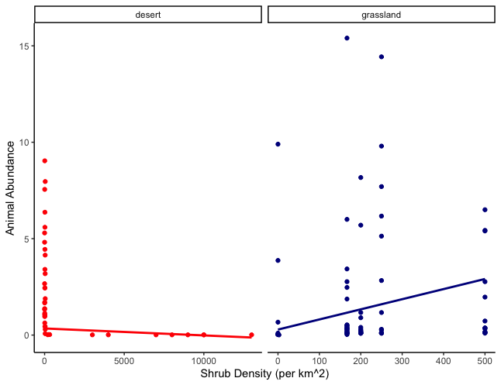

**Figure 1:** Meta-regression plot depicting the relationship between shrub density (individuals/km2) and animal abundance (number of individuals) in 2 different ecosystems. Smooth conditional means are fitted using a random-mixed model using the method maximum likelihood and are weighted by the number of days.

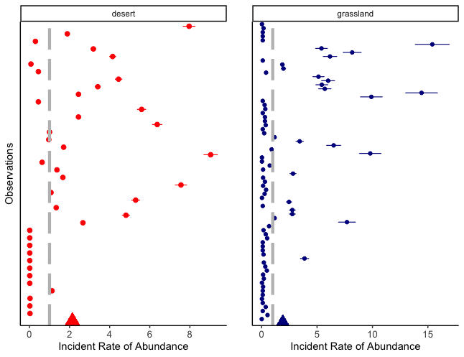

**Figure 2:** Forest plot showing the estimated effect size from random-mixed model outputs for animal abundance/number of days in 2 different macrohabitats of study. Triangles represent the grand mean for each ecosystem. Colored dots represent meta-analytic mean while lines represent the 95% confidence interval.

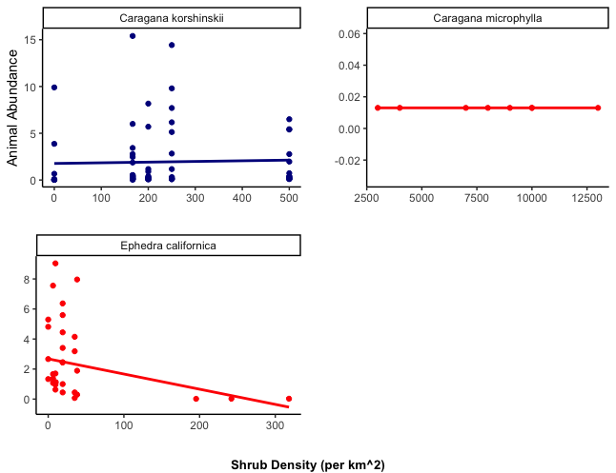

**Figure 3:** A meta-regression depicting the relationship between shrub density (individuals/km2) and animal abundance (number of individuals) amongst 3 different shrub species. Colored points represent the ecosystem with blue depicting grasslands and red depicting deserts.

**Appendix A:**

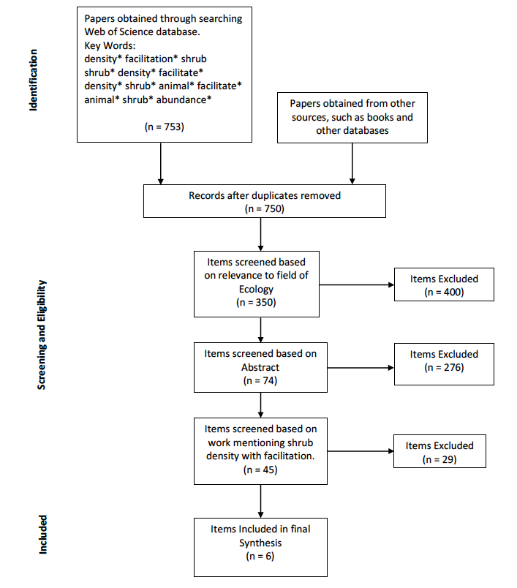

**Figure S1:** Prisma diagram used for shrub density review (Moher et al. 2009). Keywords include: 1) density*, shrub*, facil*, 2) density*, shrub* facil*, animal* 3) density*, shrub* animal* facilitate*, AND 4) animal*, shrub*, abundance* in March 2022.

**Shrub density effects on an endangered lizard of the San Joaquin Desert, California**

Mario Zuliani1*, Nargol Ghazian1, Michael F. Westphal2, H. Scott Butterfield3 and Christopher J. Lortie1.

1Department of Biological Science, York University, 4700 Keele St, Toronto, ON M3J 1P3, Canada

2US Bureau of Land Management, Central Coast Field Office, Marina, California, USA

3The Nature Conservancy, Sacramento, California, USA

*Corresponding Author: Department of Biological Science, York University, 4700 Keele St, Toronto, ON, M3J 1P3, Canada. Email: [zulianimario96@gmail.com](mailto:zulianm@yorku.ca)

**Abstract**

Facilitative associations between foundational shrub species and animal communities are frequent in desert ecosystems. Herein, we tested whether shrub density of the foundational shrub species *Ephedra californica* could be used to predict the presence of the Federally endangered blunt-nosed leopard lizard, *Gambelia sila*. To test this, we overlaid 3 years of previously analyzed lizard radio telemetry data on shrub location density maps developed using satellite imagery. We calculated the density of individual shrubs within a 20m radius around each lizard observation. We found that areas with relatively higher shrub density had a significantly higher frequency of lizard presence. As shrub density increased, we also found that lizards were located more frequently above ground versus below ground in burrows. Shrub density and cover are parsimonious and are effective at predicting presence of lizard individuals. However, density can be used as a much simpler measure.

**Keywords:** Drylands, Facilitation, Lizards, Shrubs, Density, Telemetry, Foundation species, Blunt-nosed Leopard Lizard

**Introduction**

Repopulation and protection of endangered species are driving factors for many restorative and conservation practices globally. Two key pieces of information necessary for successful habitat protection and restoration actions are understanding 1) the distribution of a species within suitable habitat and 2) how that habitat is utilized – daily as well as seasonally (Guisan &Thuiller 2005; Elith et al. 2006; Eyre et al. 2022). Overall, analyzing the relationship between animal species and the plant community that they inhabit can provide key insight into how these plant communities are used and how we manage these habitats to support animal species (Zwolak et al. 2022). In arid/semi-arid deserts and scrublands, animal species experience greater stress due to extremes in temperature and precipitation (Barrows 2011; Van de Ven et al. 2020). Refuge from abiotic (Filazzola et al. 2018; Ivey et al. 2020) and biotic stressors are a primary driver for the dependency of terrestrial organisms on ecosystem resources (Milchunas & Noy-Meir 2002; Nelson et al. 2007). In particular, thermoregulating reptilian species, such as lizards and snakes, are particularly at-risk, as extreme temperatures can only be countered by seeking refuge, including aboveground in/under vegetation or belowground in burrows (Sunday et al. 2014; Urban 2015; Germano et al. 2019; Ivey et al. 2020; Dematteis et al. 2022).

In the San Joaquin Desert of California (Germano et al. 2011), significant research has been done (Westphal et al. 2018; Germano et al. 2019; Ivey et al. 2020; Lortie et al. 2020, Gaudenti et al. 2021) on the endangered blunt-nosed leopard lizard (*Gambelia sila*), to understand how and why they use the grasslands and shrublands they inhabit (Westphal et al. 2016; Lortie et al. 2020), which in turn has been used to provide guidance for conservation and restoration actions (Kelsey et al. 2018; Stewart et al. 2019; Bryant et al. 2020). The blunt-nosed leopard lizard is able to thermoregulate, under normal conditions, by basking in direct sunlight (Westphal et al. 2018; Ivey et al. 2020; Ivy et al. 2022). However, as ambient temperatures increase above certain thresholds (20°C - 30°C; Ivey et al. 2010), these lizards are forced to take refuge, either in underground burrows or in areas with higher shrub cover across the landscape (Germano 2019; Ivey et al. 2020; Lortie et al. 2020). Challenges to thermoregulation – and dependency on the local environment for refuge – for lizards in semi-arid and arid desert environments are only becoming more acute as global warming intensifies and the likelihood of drought events increases (Dell et al. 2014; Westphal et al. 2016; Lortie et al. 2020). Documenting the activity pattern and habitat use by *G. sila* is necessary as future management strategies will need to account for the impacts ofincreasing temperatures and drought events on behaviour (Westphal et al. 2016; Ivey et al. 2022, Gaudenti et al. 2021). Previous work by Lortie et al. (2020) collected shrub cover and lizard location data at the Carrizo Plain National Monument in San Luis Obispo County, CA, USA; they demonstrated a significant relationship between increasing shrub cover and the presence of blunt-nosed leopard lizards. Here, the same lizard location dataset was used to test whether shrub density, an easier landscape measure – when compared to cover – to make each year across large areas can also be used to predict lizard presence. The importance of shrub density to associated animal communities is well-established in both the plant and animal ecology literature (McPeek 2019; Hale et al. 2020), so we believe it has significant potential as a predictor for lizard presence in the semi-arid dryland ecosystems of California’s San Joaquin Desert (Germano et al. 2011). Shrub density and cover are typically positively correlated (Roques et al. 2001). Measures of shrub density could prove to be a much more rapid and efficient means of determining both population abundance and resource use in lizards. There are few examples – at the Carrizo Plain National Monument and more broadly across the San Joaquin Desert – where shrub density has been collected and its effect tested (Westphal et al 2018; Lucero et al. 2019; Zuliani et al. 2021). In these ecosystems, shrubs – cover (Lortie et al. 2020) and likely density as well – provide benefits to local animal communities, including blunt-nosed leopard lizards, strengthening net interactions and community composition (Zuliani et al. 2021), including an individual lizard’s ability to survive. We must continue to examine key drivers and features that inform both habitat use and the needs of endangered vertebrate species as they can aid in conservation and restoration practices both at a regional and global scale (Abella et al. 2012; Miguel et al. 2020; Kingsford et al. 2021; Lortie et al. 2021).

The purpose of this study was to test if the density of a foundation shrub species, *Ephedra californica* (Mormon tea), can be used predict the presence of an endangered species of lizard, *G. sila*, in the Carrizo Plain National Monument, through the use of a combination of radio telemetry tracking and satellite imagery. We hypothesize that *G. sila* individuals will be found at higher frequency in areas of higher shrub density because of the facilitative benefits provided by shrubs, including as refuge from predators and as areas for thermoregulation. To test this hypothesis, we examined the following two predictions:

1. Higher shrub density can predict increased estimated use by *G. sila*.
2. Higher shrub density is associated with an increase in *G. sila* presence, both above and below ground.

**Methods**

***Study Species***

*Ephedra californica* is the dominant shrub species within the Elkhorn Plain in the Carrizo Plain National Monument (Lortie et al. 2021), located in south eastern San Luis Obispo County in the San Joaquin Desert of California (Germano et al. 2011). *E. californica* is considered a foundational shrub species; it provides several unique characteristics to local lizard populations, including as refuge from predators and as a place for thermoregulation, aiding overall survival in this harsh environment (Lortie et al. 2018; Braun et al. 2021; Zuliani et al. 2021). *E. californica* can reach heights of up to one meter and is native to the California Basin (Cutler 1939). With numerous twig and needle-like leaves, this species possesses unique characteristics of both gymnosperms and angiosperms, making it well-adapted to their native semi-arid and arid environment (Loera et al. 2012).

Within the San Joaquin Desert of California, and more specifically the Carrizo Plain National Monument, the blunt-nosed leopard lizard is found in both shrubbed and open areas (Westphal et al. 2018; Lortie et al. 2020; Gaudenti et al. 2021). Similar to other lizard species, these individuals use thermoregulatory behavior to reduce the overall impacts of extreme temperature conditions (Westphal et al. 2018; Lortie et al. 2020). *G. sila* is also associated with shaded areas under shrub species and in underground burrows (Lortie et al. 2020), which it uses as an additional way to regulate body temperature (Germano 2019; Ivey et al. 2022). However, with the increasing effects of global warming (Westphal et al. 2016), this species may need to shift their activity patterns to mitigate increasing temperatures (Germano 2019; Ivey et al 2020).

***Radio Telemetry & Satellite Geolocation***

A field site within the Carrizo Plain National Monument (35.11982, -119.62853) was established for this study (Noble et al. 2016; Westphal et al. 2018; Lortie et al. 2020; Zuliani et al. 2021). The site is occupied by *G. sila* (Westphal et al. 2018; Lortie et al. 2020; Ivey et al. 2022) along with *E. californica* (Westphal et al. 2018; Lortie et al. 2020; Zuliani et al. 2021). Previous studies conducted from 2016-2018 (Westphal et al. 2018; Ivey et al. 2020; Lortie et al. 2020; Ivey et al. 2022), captured around 30 *G. sila* individuals which were then collared and tracked using radio telemetry, using Holohil model BD-2T collars (Germano & Rathburn 2016), during the summer (May-July) when this species is most active (Westphal et al. 2018; Lortie et al. 2020). Each instance of *G. sila* relocation – i.e., an individual observation of each individual during data collection – was geolocated. At each location, we also collected general ecological characteristics, including whether the area was shrubbed or open and whether the lizard was above or below ground. Within the 3 years of observations, a total of 3553 relocations were recorded; data analysis focused primarily on lizard thermoregulation, shrub use, and shrub cover (Ivey et al. 2020; Lortie et al. 2020).

Shrub density data was extracted from composite satellite imagery from 2021– digital images comprised of elements from several different images – using Google Earth. Composite imagery was developed using Landsat/Copernicus satellite data, with a 30m spatial resolution. Each shrub individual located within the telemetry field site was geolocated and was given a unique identification marker. Once all *E. californica* individuals were marked, Keyhole Markup Language (kml) files containing shrub locations were extracted and converted into a useable Comma-Separated Values (csv) file. Each shrub individual was given a unique latitude and longitude value corresponding to their location within the field site. We used R version 4.2.0 (R Core Team 2022) to determine the density of *E. californica* individuals within a 20m radius of each *G. sila* relocation. 200 random shrub locations were selected and ground-truthed to determine if the satellite imagery data were accurate (Zuliani et al. 2022).

**Statistical Analysis**

The *ResourceSelection* R package (Subhash et al. 2019) was used to estimate *G. sila* use based on density and cover (Lortie et al. 2020). The resource selection probability function (rspf) was then used to estimate the probability of a lizard individual in a shrub (Lele et al. 2013; Roberts et al. 2017). Maximum likelihood estimates were then used with shrub density, shrub cover, and ground use (above vs. below) as predictor variables. Shrub density and cover were analyzed against lizard association and organized by mesohabitat observations to depict the relationship between the associated variables. AIC (Akaike information criterion) scores were generated for shrub density and shrub cover models with a 95% confidence interval (Lele et al. 2013; Roberts et al. 2017; Lortie et al. 2020). Pearson’s Product-Moment Correlation was used to determine the strength and directions of the relationship between shrub density and cover. All code, figures, statistics, and models are publicly available on GitHub (Zuliani 2022).

**Results**

There were no significant differences between the geolocated shrub densities and the ground-truthed shrub densities (Paired t-test, t = -0.048078, *df* = 389.41, p = 0.9617). Shrub density significantly predicted the presence of *G. sila*, both above and below ground (Figure 1, AIC = 11253.37, Estimate = 0.08898 ± 0.00652, p < 0.0001). Lizard relocations were significantly greater above ground at higher shrub densities (Figure 1, Estimate = -0.380932 ± 0.083427, p < 0.0001). Previous analysis of this data by Lortie et al. (2020) showed that shrub cover significantly predicted *G. sila* presence. Shrub cover and shrub density were positively correlated (Figure 2, Pearson’s Product-Moment Correlation, estimate = 0.3695, t-value=23.761, *df* = 3571, p < 0.0001).

**Discussion**

In this study, we examined whether shrub density positively predicts *G. sila* presence. We found that *G. sila* individuals were found in areas of higher shrub density, likely due to the benefits associated with this facilitative interaction. In addition, our findings suggest that increasing the density of shrubs results in a higher presence of lizards above-ground. Similar to previous work by Lortie et al. (2020), which showed that shrub cover positively predicts *G. sila* presence but plateaus around 30% cover, there is likely a threshold at which increasing shrub density plateaus and no longer leads to increasing presence of *G. sila*. Comparing our findings with that of Lortie et al. (2020) we can conclude that both shrub density and cover are parsimonious measures and are effective at predicting the presence of *G. sila*. However, density may prove to be a simpler and more efficient predictor of *G. sila* presence, since counting the number of individuals, both in the field and in satellite imagery, is easier than calculating the total area covered by a shrub.

Structural landscape features and various natural resources are important factors to consider in ecological surveys that observe both animal behavior and association. Typically, in semi-arid and arid ecosystems – where the environment is harsher because of high temperatures and low precipitation – shrub species provide benefits to local animal communities by buffering climatological extremes (Eldridge & Soliveres 2014; Maestre et al. 2014; Schooley et al. 2018). Additional benefits include acting as a refuge from predation, and other abiotic and biotic conditions (Bruno et al. 2003; Noble et al. 2016; Filazzola et al. 2017; Westphal et al. 2018; Ivey et al. 2022). Collectively, the benefits associated with these foundational shrub species likely increase the overall survival of G. sila.

Not all foundation shrub species impacts are positive; for example, in this same ecosystem, increases in shrub density lead to increases in the amount of plant (e.g., grasses, forbs) matter growing under shrubs, which can potentially hinder lizard foraging activity and predator avoidance (Zuliani et al. 2021; Lortie et al. 2021). *E. californica* also has been shown to promote the growth of non-native invasive plant species, which can further impact shrub-animal associations (Lucero et al. 2019). Collectively, these “negative” shrub effects likely do not outweigh the largely beneficial associations blunt-nosed leopard lizards experience with shrubs.

Our study found that lizards were predicted to be above ground at higher densities as shrub density increased, suggesting that individuals are utilizing shrubs – when available at certain densities – more often than staying below ground in their burrows to thermoregulate. Shrub cover is crucial to lizard thermoregulation and can be utilized – in areas where shrubs exist – to predict the likelihood of individual lizard observations (Filazzola et al. 2017; Lortie et al. 2020; Zuliani et al. 2021). This is in contrast to lizard individuals in shrubless (or open) areas, which are necessarily more reliant on below-ground burrows to thermoregulate (Germano & Rathbun 2016; Ivey et al 2020). Continuing to examine the influence shrub density, and by extension shrub cover, have on the thermoregulation, behavior, and associations of blunt-nosed leopard lizards could further illustrate how these resources are beneficial to this endangered species.

**Conclusion**

Our study concluded that shrub density can be used to predict the presence of blunt*-*nosed leopard lizard; thus, guiding species conservation and restoration through the preservation of shrubbed landscapes in the San Joaquin Desert. These findings build on the previous work conducted by Lortie et al. (2020) which showed that shrub cover can be used to predict lizard presence. Shrub density itself has a strong positive correlation with shrub cover suggesting that both cover and density are viable factors that can be used to predict lizard presence. However, we suggest that the utilization of shrub density can prove to be a more effective measure of predicting lizard presence as it is a relatively rapid and simple measure that can be recoded both in-field and with satellite imagery. Our findings suggest that restoring areas with *E. californica* or preserving already established areas of *E. californica*, can benefit blunt-nosed leopard lizard populations, resulting in a higher presence within these areas. Restorative practices should not only continue to protect current shrubs but should also consider increasing the introduction of more foundational shrubs native to the ecosystem.

**Project Funding**

This research was made possible through the Natural Sciences and Engineering Research Council of Canada (NSERC NG) grant awarded to CJL and the York University Faculty of Graduate Studies (FGS) award granted to Mario Zuliani.

**Author**’**s contributions**

MZ and CJL designed the study; MZ, CJL, HSB, and MFW contributed to the methodologies and study design and edited the manuscript; JB developed spatial code; MZ, NG, and CJL wrote the manuscript; MZ and CJL analyzed the data; NG and CJL thoroughly edited the manuscript.

**Literature Cited**

Abella, S. R., Craig, D. J., Smith, S. D., & Newton, A. C. (2012). Identifying native vegetation for reducing exotic species during the restoration of desert ecosystems. Restoration Ecology, 20(6), 781–787. <https://doi.org/10.1111/j.1526-100X.2011.00848.x>

Barrows, C. W. (2011). Sensitivity to climate change for two reptiles at the Mojave–Sonoran Desert interface. Journal of Arid Environments, 75(7), 629–635. https://doi.org/10.1016/j.jaridenv.2011.01.018

Braun, J., Westphal, M., & Lortie, C. J. (2021). The shrub Ephedra californica facilitates arthropod communities along a regional desert climatic gradient. Ecosphere, 12(9). <https://doi.org/10.1002/ecs2.3760>

Bruno, J. F., Stachowicz, J. J., & Bertness, M. D. (2003). Inclusion of facilitation into ecological theory. Trends in Ecology & Evolution, 18(3), 119–125.https://doi.org/10.1016/S0169- 5347(02)00045-9

Bryant, B. P., Kelsey, T. R., Vogl, A. L., Wolny, S. A., MacEwan, D., Selmants, P. C., Biswas, T., & Butterfield, H. S. (2020). Shaping land use change and ecosystem restoration in a water-stressed agricultural landscape to achieve multiple benefits. Frontiers in Sustainable Food Systems, 4, 138. <https://doi.org/10.3389/fsufs.2020.00138>

Cutler, H. C. (1939). Monograph of the North American species of the Genus Ephedra. Annals of the Missouri Botanical Garden, 26(4), 373. <https://doi.org/10.2307/2394299>

Dell, A. I., Pawar, S., & Savage, V. M. (2014). Temperature dependence of trophic interactions are driven by asymmetry of species responses and foraging strategy. Journal of Animal Ecology, 83(1), 70–84. https://doi.org/10.1111/1365-2656.12081

Dematteis, A., Stellatelli, O. A., Block, C., Vega, L. E., Dajil, J. E., & Cruz, F. B. (2022). Correspondence between thermal biology and locomotor performance in a liolaemid lizard from the southeastern coastal Pampas of Argentina. Journal of Thermal Biology, 105, 103173. <https://doi.org/10.1016/j.jtherbio.2021.103173>

Eldridge, D. J., & Soliveres, S. (2014). Are shrubs really a sign of declining ecosystem function? Disentangling the myths and truths of woody encroachment in Australia. Australian Journal of Botany, 62(7), 594. <https://doi.org/10.1071/BT14137>

Elith, J., H. Graham, C., P. Anderson, R., Dudík, M., Ferrier, S., Guisan, A., J. Hijmans, R., Huettmann, F., R. Leathwick, J., Lehmann, A., Li, J., G. Lohmann, L., A. Loiselle, B., Manion, G., Moritz, C., Nakamura, M., Nakazawa, Y., McC. M. Overton, J., Townsend Peterson, A., E. Zimmermann, N. (2006). Novel methods improve prediction of species’ distributions from occurrence data. Ecography, 29(2), 129–151. https://doi.org/10.1111/j.2006.0906-7590.04596.x

Eyre, A. C., Briscoe, N. J., Harley, D. K. P., Lumsden, L. F., McComb, L. B., & Lentini, P. E. (2022). Using species distribution models and decision tools to direct surveys and identify potential translocation sites for a critically endangered species. Diversity and Distributions, 28(4), 700–711. <https://doi.org/10.1111/ddi.13469>

Filazzola, A., Liczner, A. R., Westphal, M., & Lortie, C. J. (2018). The effect of consumer pressure and abiotic stress on positive plant interactions are mediated by extreme climatic events. New Phytologist, 217(1), 140–150. https://doi.org/10.1111/nph.14778

Filazzola, A., Westphal, M., Powers, M., Liczner, A. R., (Smith) Woollett, D. A., Johnson, B., & Lortie, C. J. (2017). Non-trophic interactions in deserts: Facilitation, interference, and an endangered lizard species. Basic and Applied Ecology, 20, 51–61. <https://doi.org/10.1016/j.baae.2017.01.002>

Gaudenti, N., Nix, E., Maier, P., Westphal, M. F., & Taylor, E. N. (2021). Habitat heterogeneity affects the thermal ecology of an endangered lizard. Ecology and Evolution, 11(21), 14843–14856. <https://doi.org/10.1002/ece3.8170>

Germano, D. J. (2019). Activity and thermal biology of blunt-nosed leopard lizards (Gambelia sila) in the San Joaquin Desert of California. Western North American Naturalist, 79(3), 428. <https://doi.org/10.3398/064.079.0311>

Germano, D. J., & Rathbun, G. B. (2016). Home range and habitat use by blunt-nosed leopard lizards in the southern San Joaquin Desert of California. Journal of Herpetology, 50(3), 429–434. <https://doi.org/10.1670/15-006>

Germano, D. J., Rathbun, G. B., Saslaw, L. R., Cypher, B. L., Cypher, E. A., & Vredenburgh, L. M. (2011). The San Joaquin Desert of California: Ecologically misunderstood and overlooked. Natural Areas Journal, 31(2), 138–147. https://doi.org/10.3375/043.031.0206

Guisan, A., & Thuiller, W. (2005). Predicting species distribution: Offering more than simple habitat models. Ecology Letters, 8(9), 993–1009. https://doi.org/10.1111/j.1461- 0248.2005.00792.x

Hale, K. R. S., Valdovinos, F. S., & Martinez, N. D. (2020). Mutualism increases diversity, stability, and function of multiplex networks that integrate pollinators into food webs. Nature Communications, 11(1), 2182. https://doi.org/10.1038/s41467-020-15688-w

Ivey, K. N., Cornwall, M., Crowell, H., Ghazian, N., Nix, E., Owen, M., Zuliani, M., Lortie, C. J., Westphal, M., & Taylor, E. (2020). Thermal ecology of the federally endangered blunt-nosed leopard lizard (Gambelia sila). Conservation Physiology, 8(1), coaa014. https://doi.org/10.1093/conphys/coaa014

Ivey, K. N., Cornwall, M. B., Gaudenti, N., Maier, P. H., Ghazian, N., Owen, M., Nix, E., Zuliani, M., Lortie, C. J., Westphal, M. F., & Taylor, E. N. (2022). Temperature-based activity estimation accurately predicts surface activity, but not microhabitat use, in the Endangered heliothermic lizard Gambelia sila. Amphib. Reptile Conserv., 16(1), 10.

Kelsey, R., Hart, A., Butterfield, H. S. & Vink, D. (2018). Groundwater sustainability in the San Joaquin Valley: Multiple benefits if agricultural lands are retired strategically. California Agriculture 72(3): 151-154. https://doi.org/10.3733/ca.2018a0029.

Kingsford, R. T., West, R. S., Pedler, R. D., Keith, D. A., Moseby, K. E., Read, J. L., Letnic, M., Leggett, K. E. A., & Ryall, S. R. (2021). Strategic adaptive management planning— Restoring a desert ecosystem by managing introduced species and native herbivores and reintroducing mammals. Conservation Science and Practice, 3(2). <https://doi.org/10.1111/csp2.268>

Lele, S. R., Merrill, E. H., Keim, J., & Boyce, M. S. (2013). Selection, use, choice and occupancy: Clarifying concepts in resource selection studies. Journal of Animal Ecology, 82(6), 1183–1191. https://doi.org/10.1111/1365-2656.12141

Loera, I., Sosa, V., & Ickert-Bond, S. M. (2012). Diversification in North American arid lands: Niche conservatism, divergence and expansion of habitat explain speciation in the genus Ephedra. Molecular Phylogenetics and Evolution, 65(2), 437–450. <https://doi.org/10.1016/j.ympev.2012.06.025>

Lortie, C. J., Braun, J., Westphal, M., Noble, T., Zuliani, M., Nix, E., Ghazian, N., Owen, M., & Butterfield, H.S. (2020). Shrub and vegetation cover predict resource selection use by an endangered species of desert lizard. Scientific Reports, 10(1), 4884. https://doi.org/10.1038/s41598-020-61880-9

Lortie, C. J., Filazzola, A., Brown, C., Lucero, J., Zuliani, M., Ghazian, N., Haas, S., Owen, M., Butterfield, H. S., Nix, E., & Westphal, M. (2021). Facilitation promotes plant invasions and indirect negative interactions. Oikos, 130(7), 1056–1061. <https://doi.org/10.1111/oik.08443>

Lortie, C. J., Gruber, E., Filazzola, A., Noble, T., & Westphal, M. (2018). The Groot Effect: Plant facilitation and desert shrub regrowth following extensive damage. Ecology and Evolution, 8(1), 706–715. <https://doi.org/10.1002/ece3.3671>

Lortie, C. J., Noble, T., Zuliani, M., Westphal, F. M., Nix, E., Ghazian, N., et al. (2019): Telemetry of the lizard species Gambelia sila at Carrizo Plain National Monument. figshare. Dataset. https://doi.org/10.6084/m9.figshare.8239667.v1

Lortie, C. J., Zuliani, M., Ghazian, N., Haas, S., Braun, J., Owen, M., Miguel, F., Seifan, M., Filazzola, A., & Lucero, J. (2021). Too much of a good thing: Shrub benefactors are less important in higher diversity arid ecosystems. Journal of Ecology, 1365-2745.13596. <https://doi.org/10.1111/1365-2745.13596>

Lucero, J. E., Noble, T., Haas, S., Westphal, M., Butterfield, H. S., & Lortie, C. J. (2019). The dark side of facilitation: Native shrubs facilitate exotic annuals more strongly than native annuals. NeoBiota, 44, 75–93. <https://doi.org/10.3897/neobiota.44.33771>

Maestre, F. T., Eldridge, D. J., Soliveres, S., Kéfi, S., Delgado-Baquerizo, M., Bowker, M. A., García-Palacios, P., Gaitán, J., Gallardo, A., Lázaro, R., & Berdugo, M. (2016). Structure and functioning of dryland ecosystems in a changing world. Annual Review of Ecology, Evolution, and Systematics, 47(1), 215–237. [https://doi.org/10.1146/annurev- ecolsys-121415-032311](https://doi.org/10.1146/annurev-ecolsys-121415-032311)

McPeek, M. A. (2019). Mechanisms influencing the coexistence of multiple consumers and multiple resources: Resource and apparent competition. Ecological Monographs, 89(1), e01328. https://doi.org/10.1002/ecm.1328

Miguel, M. F., Butterfield, H. S., & Lortie, C. J. (2020). A meta-analysis contrasting active versus passive restoration practices in dryland agricultural ecosystems. PeerJ, 8, e10428. <https://doi.org/10.7717/peerj.10428>

Milchunas, D. G., & Noy-Meir, I. (2002). Grazing refuges, external avoidance of herbivory and plant diversity. Oikos, 99(1), 113–130. https://doi.org/10.1034/j.1600- 0706.2002.990112.x

Nelson, J. L., Cypher, B. L., Bjurlin, C. D., & Creel, S. (2007). Effects of habitat on competition between kit foxes and coyotes. Journal of Wildlife Management, 71(5), 1467–1475. https://doi.org/10.2193/2006-234

Noble, T. J., Lortie, C. J., Westphal, M., & Butterfield, H. S. (2016). A picture is worth a thousand data points: An imagery dataset of paired shrub-open microsites within the Carrizo Plain National Monument. GigaScience, 5(1), 40. <https://doi.org/10.1186/s13742-016-0145-2>

R Core Team (2022). R: A language and environment for statistical computing. R Foundation for Statistical Computing, Vienna, Austria. URL https://www.R-project.org/.

Roberts, D. R., Bahn, V., Ciuti, S., Boyce, M. S., Elith, J., Guillera-Arroita, G., Hauenstein, S., Lahoz-Monfort, J. J., Schröder, B., Thuiller, W., Warton, D. I., Wintle, B. A., Hartig, F., & Dormann, C. F. (2017). Cross-validation strategies for data with temporal, spatial, hierarchical, or phylogenetic structure. Ecography, 40(8), 913–929. https://doi.org/10.1111/ecog.02881

Roques, K. G., O’Connor, T. G., & Watkinson, A. R. (2001). Dynamics of shrub encroachment in an African savanna: Relative influences of fire, herbivory, rainfall and density dependence: Dynamics and causes of shrub encroachment. Journal of Applied Ecology, 38(2), 268–280. <https://doi.org/10.1046/j.1365-2664.2001.00567.x>

Schooley, R. L., Bestelmeyer, B. T., & Campanella, A. (2018). Shrub encroachment, productivity pulses, and core‐transient dynamics of Chihuahuan Desert rodents. Ecosphere, 9(7). <https://doi.org/10.1002/ecs2.2330>

Stewart, J. A. E., Butterfield, H. S., Richmond, J. Q., Germano, D. J., Westphal, M. F., Tennant, E. N., & Sinervo, B. (2019). Habitat restoration opportunities, climatic niche contraction, and conservation biogeography in California’s San Joaquin Desert. PLOS ONE, 14(1), e0210766. <https://doi.org/10.1371/journal.pone.0210766>

Sunday, J. M., Bates, A. E., Kearney, M. R., Colwell, R. K., Dulvy, N. K., Longino, J. T., & Huey, R. B. (2014). Thermal-safety margins and the necessity of thermoregulatory behavior across latitude and elevation. Proceedings of the National Academy of Sciences, 111(15), 5610–5615. https://doi.org/10.1073/pnas.1316145111

Urban, M. C. (2015). Accelerating extinction risk from climate change. Science, 348(6234), 571–573. https://doi.org/10.1126/science.aaa4984

Van de Ven, T. M. F. N., McKechnie, A. E., Er, S., & Cunningham, S. J. (2020). High temperatures are associated with substantial reductions in breeding success and offspring quality in an arid-zone bird. Oecologia, 193(1), 225–235. https://doi.org/10.1007/s00442- 020-04644-6

Westphal, M. F., Noble, T., Butterfield, H. S., & Lortie, C. J. (2018). A test of desert shrub facilitation via radiotelemetric monitoring of a diurnal lizard. Ecology and Evolution, 8(23), 12153–12162. https://doi.org/10.1002/ece3.4673

Westphal, M. F., Stewart, J. A. E., Tennant, E. N., Butterfield, H. S., & Sinervo, B. (2016). Contemporary drought and future effects of climate change on the endangered

blunt-nosed leopard lizard, *Gambelia sila*. PLOS ONE, 11(5), e0154838. <https://doi.org/10.1371/journal.pone.0154838>

Zuliani, M. 2022. Github - <https://mariozuliani.github.io/Shrub-Lizard-Test-Repo/Index3.html>

Zuliani, M., Ghazian, N., Lortie, C. J. (2022): A ground-truth test of shrub density point counts on Google Earth in Carrizo Plain National Monument, California. figshare. Dataset. https://doi.org/10.6084/m9.figshare.19783504.v1

Zuliani, M., Ghazian, N., & Lortie, C. J. (2021). Shrub density effects on the community structure and composition of a desert animal community. Wildlife Biology, 2021(2). https://doi.org/10.2981/wlb.00774

Zwolak, R., Celebias, P., & Bogdziewicz, M. (2022). Global patterns in the predator satiation effect of masting: A meta-analysis. Proceedings of the National Academy of Sciences, 119(11), e2105655119. <https://doi.org/10.1073/pnas.2105655119>

**Figures:**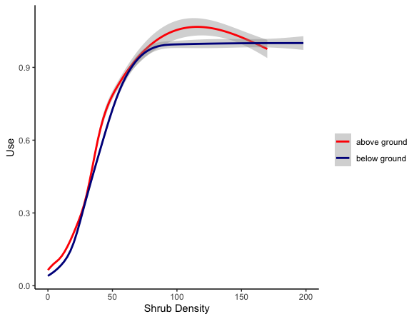

**Figure 1:** The relative effects of shrub density on *Gambelia sila* estimate resourceuse above and below ground for each individual relocation. Radio telemetry data were overlaid with geolocated shrub data, via satellite imagery, to determine the shrub density around each *Gambelia* individual. The data were then grouped by above and belowground. Shaded areas show a 95% confidence interval band for the lines of best fit.

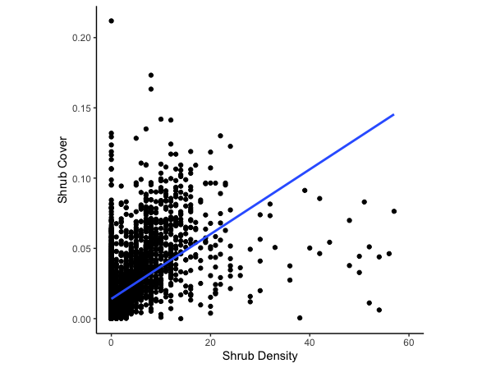

**Figure 2:** The relationship between shrub density and shrub cover within the Carrizo Plain National Monument study site. Total shrub density was overlaid with calculated shrub cover data to determine the correlation between the two variables. Pearson’s product-moment correlation estimate = 0.3694847, p-value < 0.0001.